STUDY NOTES

Why Humans Rarely Eat Predators
Deep dive
Humans are omnivores that can eat almost anything, yet top predators such as lions, sharks and wolves are almost never on the menu. This lesson explains the ecological, economic, health and cultural reasons behind that pattern, and why it is a tendency rather than a rule.

1. The energy rule in food chains
Energy is lost at each step of a food chain, and only about ten percent is passed on to the next level. Because of this steep loss, the amount of energy available to top predators is very small compared with the plants at the base. The result is that predators are naturally rare, since an ecosystem can support many herbivores but only a few carnivores.

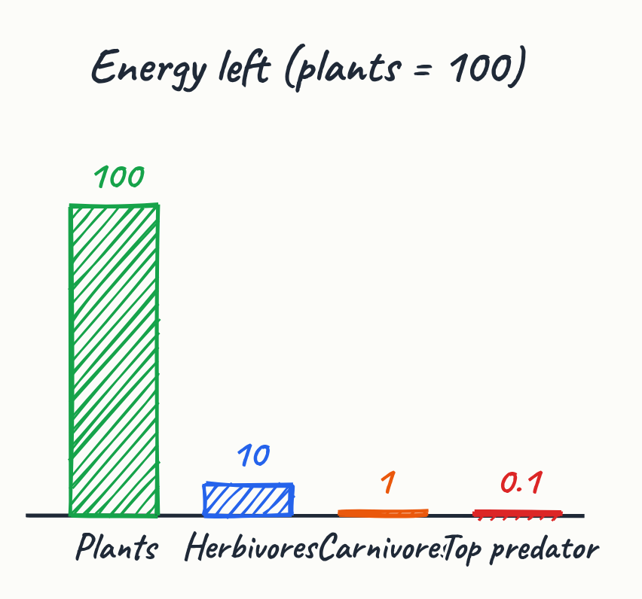
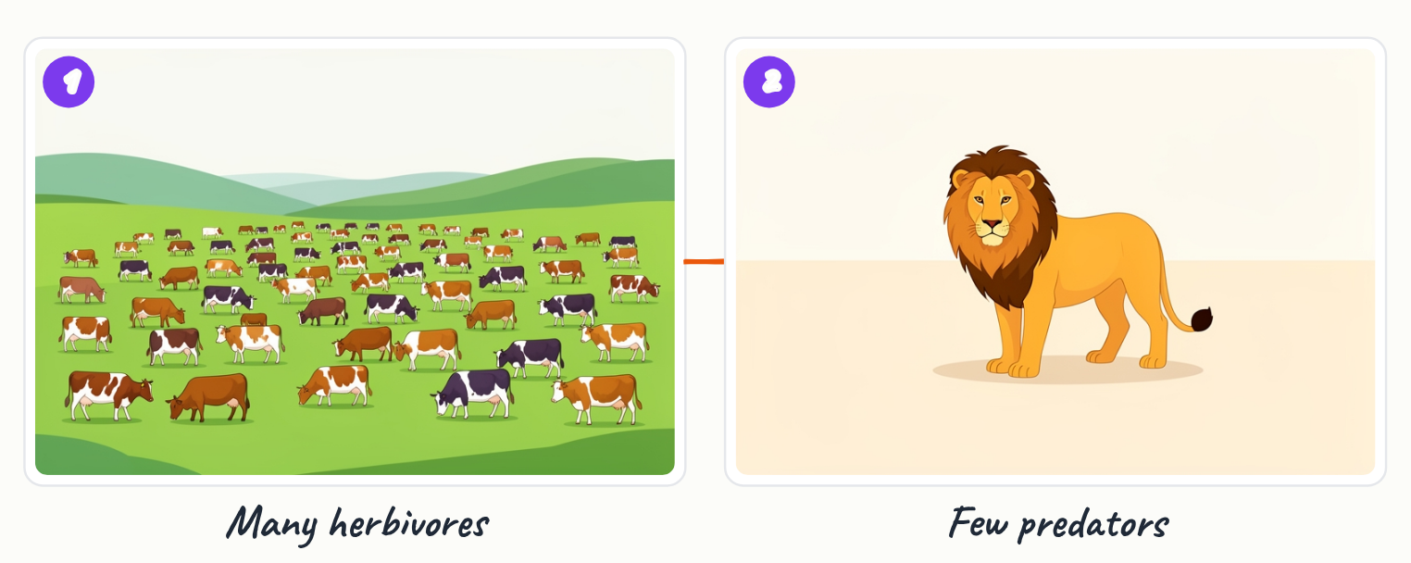
- About 90 percent of energy is lost at each step (a rough textbook figure).
- After three steps, only about one thousandth of the plants' energy remains at the top.
- A planet can feed millions of cows but only a few lions.

Key terms
Food chain | A sequence of organisms in which each one is eaten by the next, passing energy along.

2. Cost of farming and feeding carnivores
Raising a carnivore is inefficient because it sits several steps above the plants that capture the energy. Each extra step wastes energy, so growing food for a predator costs far more than growing food for people directly.
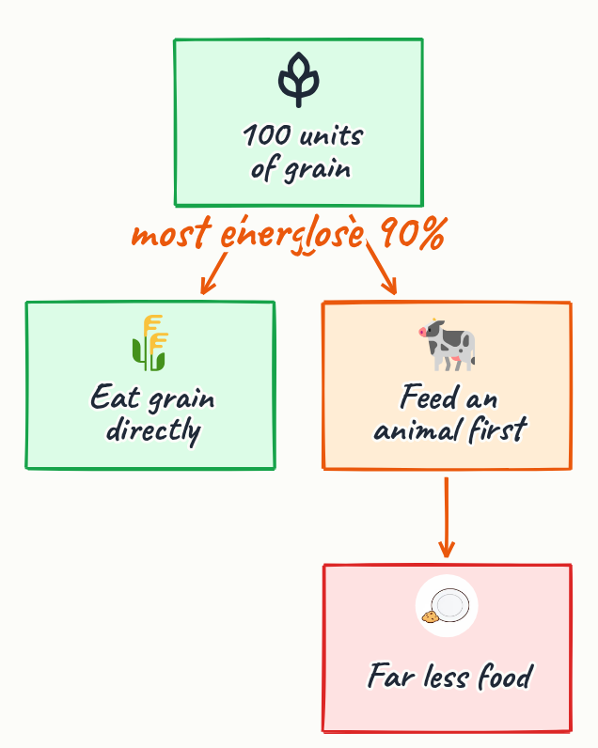
- A carnivore requires plants, then herbivores, then the predator itself.
- Energy is wasted at every additional link in that chain.

3. Biomagnification of toxins
Some toxins do not break down in the body, so they accumulate in fat and become more concentrated at each step up the food chain. Top predators therefore often carry far higher toxin levels than the organisms they eat. Mercury in large fish such as swordfish and shark is a well-known example, and health agencies advise pregnant women to limit their intake.
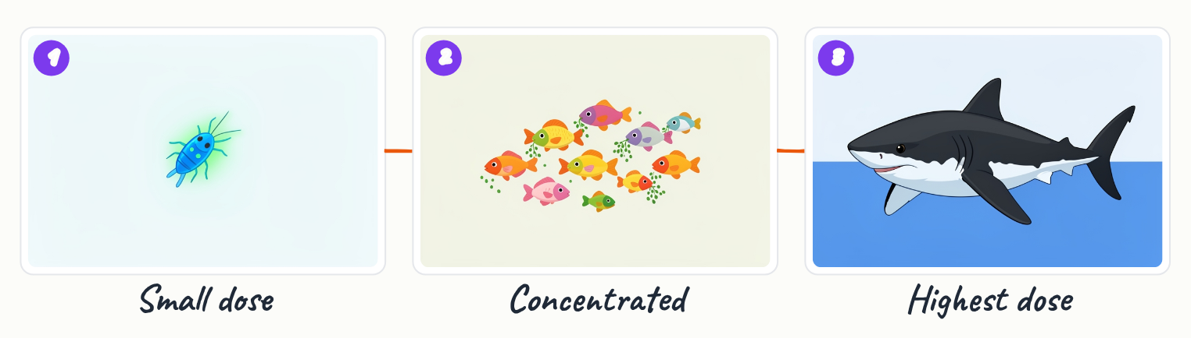

- Toxins that resist breakdown concentrate in body fat as they move up the chain.
- Large predatory fish like swordfish and shark are a real mercury example.

Key terms
Biomagnification | The increasing concentration of a non-degradable substance at each higher level of a food chain.

4. Parasites, disease and danger
Many carnivores carry parasites that spread when their meat is eaten, especially if it is undercooked. Hunting dangerous animals also carries serious risk, while herding a sheep is comparatively safe, so the effort-to-reward balance favours easier prey.
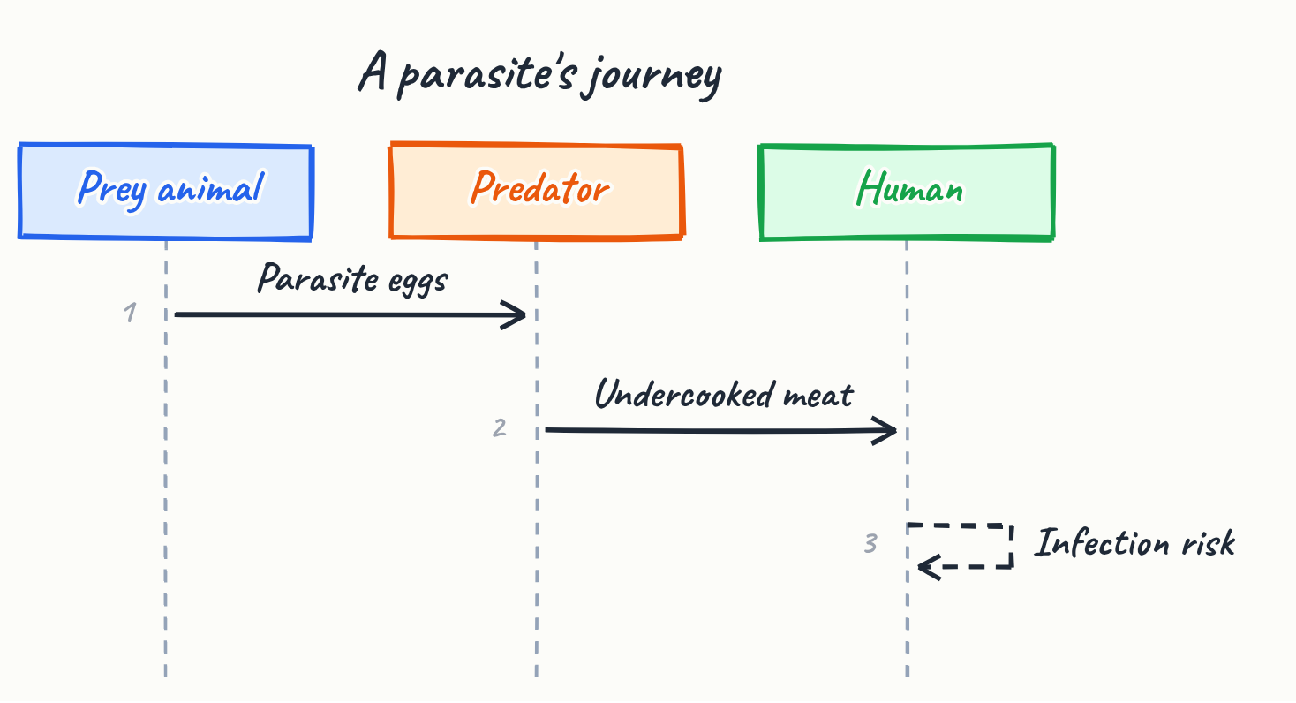
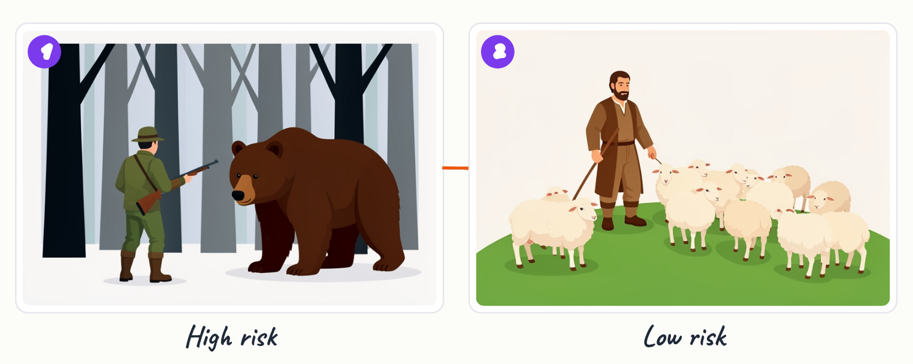
- Parasites often pass to humans through infected prey that is undercooked.
- Hunting a wolf or bear risks life, whereas herding sheep risks almost nothing.

5. Domestication of herbivores
Humans have tamed animals that suit farming: herbivores that grow quickly, breed in captivity and tolerate crowded conditions. Cows and chickens are the classic examples, and this domestication makes them a far more practical food source than wild predators.
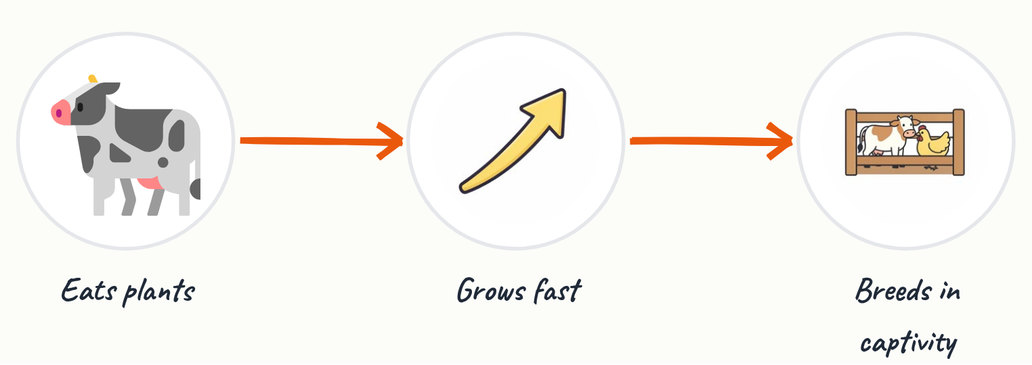
- Suitable animals grow fast, breed in captivity and tolerate crowds.
- Cows and chickens are classic examples of domesticated herbivores.

6. Predators are not forbidden, and a tendency, not a law
Predators are not inherently poisonous or forbidden, and humans do eat some of them, including tuna, pigs and shark in some places. Pigs are omnivores and tuna are predators, so the pattern reflects cost and availability rather than a fixed rule. Humans are themselves top predators, and cannibalism has occurred historically, though it carries disease risks, notably prion diseases.
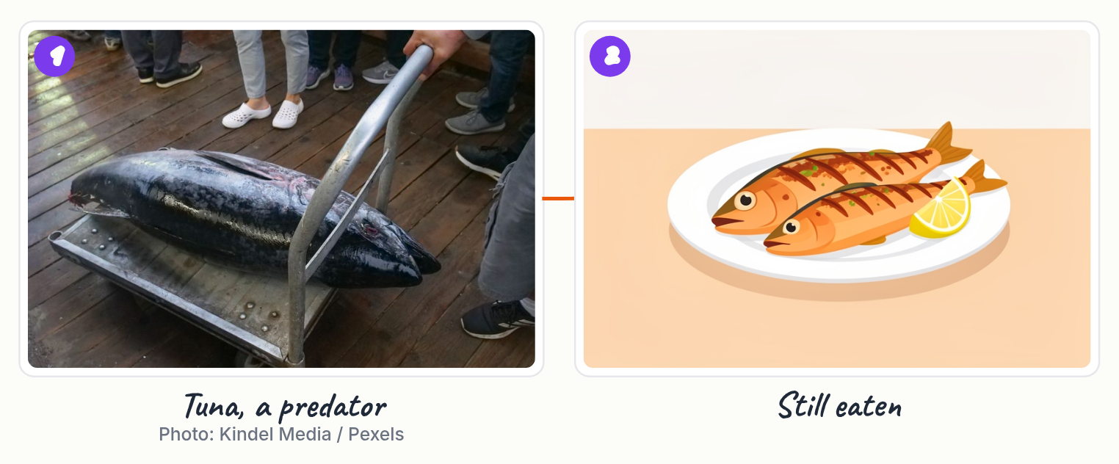
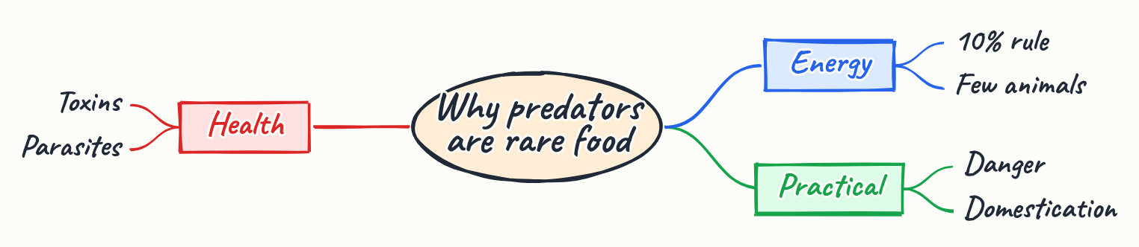
- Tuna, pigs and, in some places, shark are eaten by humans.
- The rule is driven by cost and availability, not by nature forbidding it.
- Eating humans carries specific disease risk, such as prion diseases.

Key terms
Prion disease | A group of fatal neurodegenerative diseases caused by misfolded proteins that can be transmitted by eating infected tissue.

Key points
- Energy loss of roughly 90 percent per step makes top predators scarce.
- Feeding a carnivore wastes energy at every extra step, making it costly.
- Biomagnification concentrates non-degradable toxins in predators, such as mercury in swordfish and shark.
- Predators can carry parasites and disease, and hunting them is dangerous.
- Humans favour domesticated herbivores that grow fast and breed in captivity.
- The pattern is a tendency driven by cost and availability, not a law; humans do eat some predators.

Summary
Humans rarely eat top predators because energy is lost at each step of the food chain, leaving few predators to hunt and making them expensive to raise. Predators also tend to accumulate toxins, carry parasites and are dangerous to hunt, while domesticated herbivores are easier and safer to farm. These factors make predators an unlikely food choice, but they are not forbidden, and humans eat tuna, pigs and some sharks.

Practice questions
1. Using the 10 percent energy rule, roughly how much of a plant's energy reaches a predator three steps up the chain?
______________________________________________________________________
2. Why does biomagnification affect top predators more than herbivores?
______________________________________________________________________
3. Why is raising a lion for meat less efficient than raising cattle?
______________________________________________________________________
4. Why does the rule of avoiding predators count as a tendency rather than a law?
______________________________________________________________________
5. Explain why cannibalism is considered a special case in this topic.
______________________________________________________________________

Quick quiz
1. Why are top predators scarce in nature?
(a) Their meat is always poisonous
(b) Energy is lost at each step of the food chain
(c) Humans hunted them all

Answer key

Practice questions
1. About one thousandth (0.1 percent) of the plants' energy remains after three steps.
2. Non-degradable toxins accumulate in body fat and become more concentrated at each step up the food chain, so top predators carry the highest levels.
3. A lion requires plants, then herbivores, then the lion itself, so energy is wasted at each extra step; cattle eat plants directly.
4. Humans do eat some predators, such as tuna and shark, because the choice depends on cost and availability rather than any natural prohibition.
5. Humans are top predators, so eating humans does not fit the usual cost pattern; instead it carries specific disease risks, such as prion diseases.

Quick quiz
1. (b) Energy is lost at each step of the food chain — The misconception is that scarcity comes from poison or hunting; it comes from energy loss at each level.

