STUDY NOTES

How an Induction Motor Works
Simple
This lesson explains how an induction motor makes its rotor spin without any electrical connection to it. Induction motors power fans, pumps and factory machines, so understanding them is useful in everyday engineering.

1. Main parts of the motor
An induction motor has two main parts: a fixed outer stator and a spinning inner rotor. The rotor is shaped like a hamster wheel made of metal bars, which is why it is called a squirrel cage. The key feature is that no wires connect to the rotor; only the stator receives electricity.
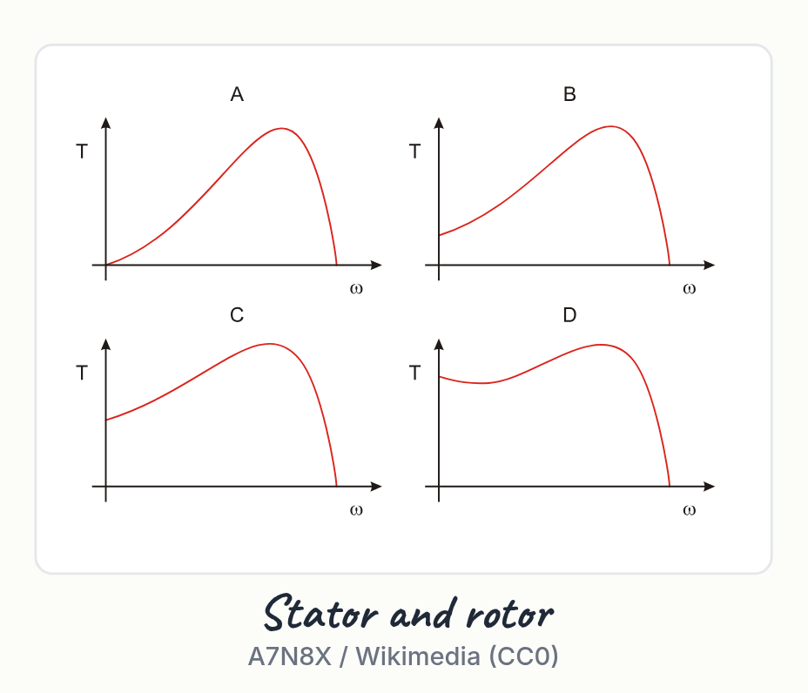
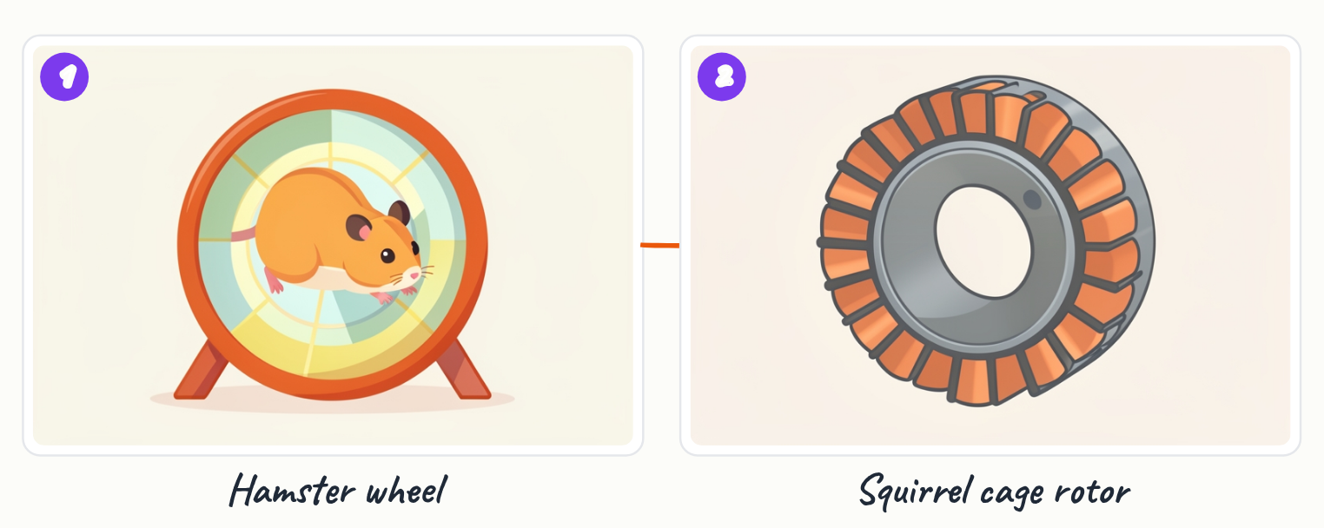
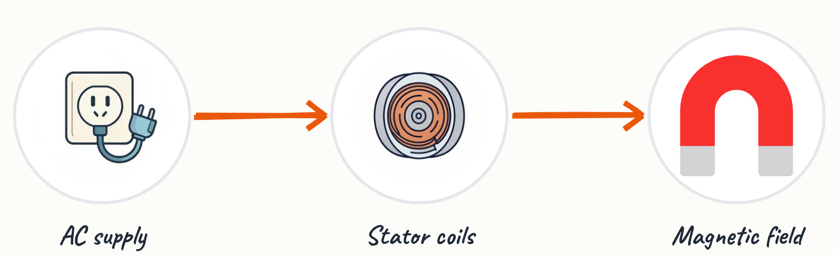
- Stator: the fixed outer part that receives the electrical supply
- Rotor: the spinning inner part, built from metal bars
- The rotor has no electrical connection to the supply

Key terms
Stator | The fixed outer part of the motor that carries the supply coils.
Squirrel cage | The name for a rotor made of metal bars shaped like a hamster wheel.

2. The rotating magnetic field
When the stator coils receive alternating current, their combined magnetic field appears to rotate around the stator, much like a spinning pattern of lights. This is called the rotating magnetic field. Its speed depends on the supply frequency and the number of poles.
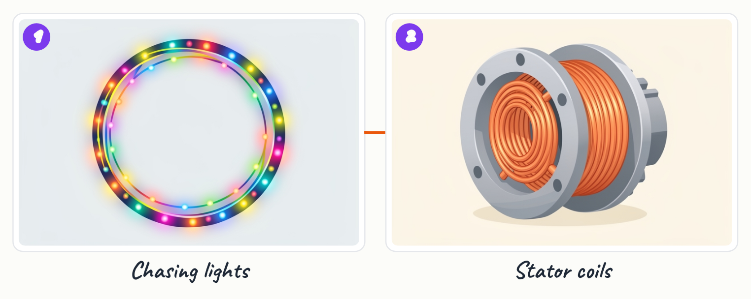
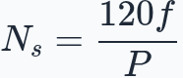
- The field is produced by the stator coils, not by the rotor
- Field speed is given by N_s = 120 f / P, where f is frequency and P is the number of poles

Key terms
Rotating magnetic field | A magnetic field produced by the stator that moves around the motor.

3. How the rotor is driven
The moving stator field cuts through the rotor bars and induces a current in them. A current in a magnetic field experiences a force, so the rotor bars are pushed and the rotor turns. A useful comparison is a magnet dragged under a metal toy car, which follows the moving magnet.
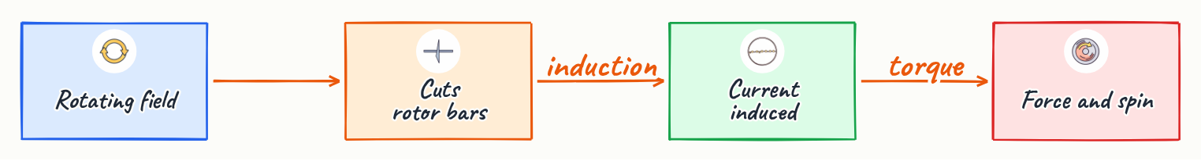
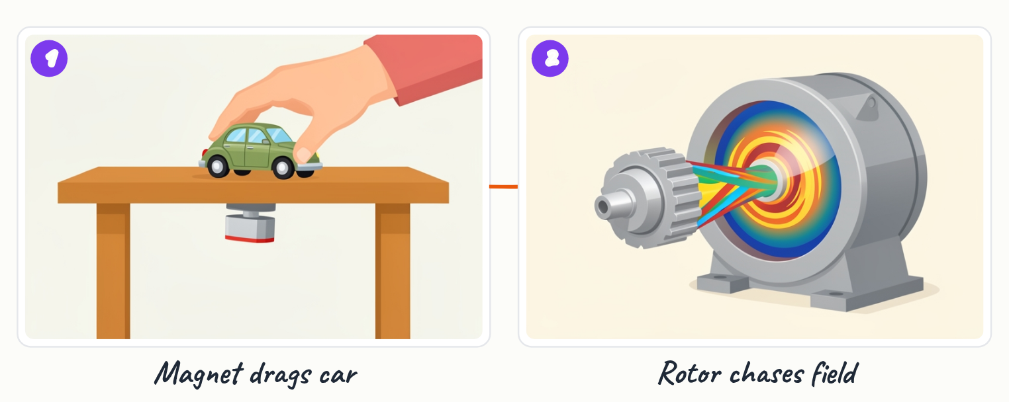
- Induced current in the rotor comes from the moving field, not from a wire
- Force on a current in a magnetic field pushes the rotor around

4. Slip and asynchronous speed
The rotor always spins slightly slower than the rotating field. If it matched the field speed, no relative motion would occur and no current would be induced. The difference between the two speeds is called slip, usually expressed as a fraction or percentage of the field speed.
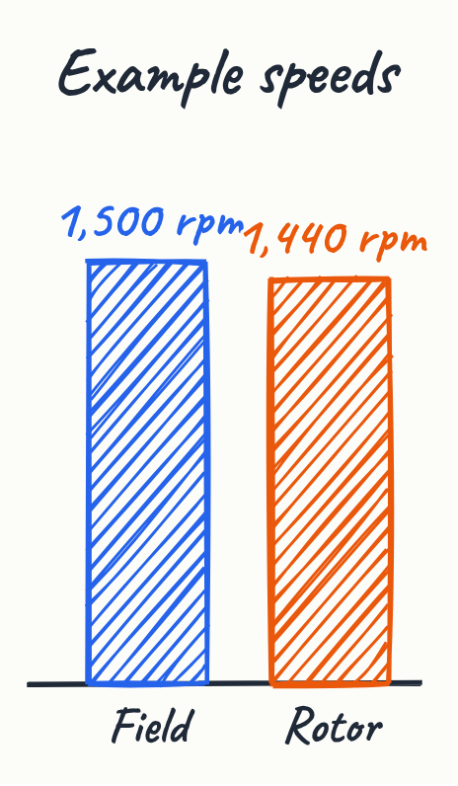
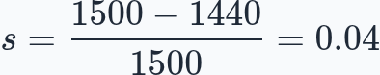
- Because the rotor lags the field, the motor is called asynchronous
- Example: field at 1500 rpm and rotor at 1440 rpm gives slip s = (1500 - 1440) / 1500 = 0.04, or 4 percent

Key terms
Slip | The difference between field speed and rotor speed, as a fraction of field speed.

5. Why induction motors are popular
Induction motors are inexpensive, robust, and able to start on their own without extra starting equipment. They also have no brushes, which means there are no parts that wear out through rubbing contact.

- Cheap to make
- Tough and reliable
- Self-starting
- No brushes to wear out

6. Summary of the operation
A rotating stator field induces a current in the rotor, the current experiences a force in that field, and the rotor turns just behind the field speed.

Key points
- The stator is fixed and receives the supply; the rotor has no electrical connection.
- Alternating current in the stator produces a rotating magnetic field.
- The moving field induces current in the rotor bars, and the force on that current turns the rotor.
- The rotor spins slightly slower than the field; this difference is slip.
- Induction motors are cheap, robust, self-starting, and brushless.

From the 3D model: Induction motor
- Speed = 120 x frequency / poles, in rpm
- A 50 Hz, 4-pole motor: 1500 rpm field
- Rotor runs a few percent slower
- Invented by Nikola Tesla in 1887

Summary
An induction motor works because the stator produces a rotating magnetic field that induces current in the rotor. That current experiences a force, so the rotor turns. The rotor must lag behind the field, since matching speeds would stop the induced current. This lag, called slip, is central to how these motors operate.

Practice questions
1. Which part of the induction motor receives the electrical supply?
______________________________________________________________________
2. What is the rotor called when it is shaped like a hamster wheel made of metal bars?
______________________________________________________________________
3. A field turns at 1500 rpm and the rotor turns at 1440 rpm. What is the slip?
______________________________________________________________________
4. Why must the rotor spin slower than the rotating field?
______________________________________________________________________
5. Why do induction motors have no brushes to wear out, and why does this matter?
______________________________________________________________________

Quick quiz
1. Why does the rotor run slower than the field?
(a) To save electricity
(b) Relative motion is needed to induce current
(c) The bars are too heavy

Answer key

Practice questions
1. The stator, the fixed outer part. The rotor has no electrical connection.
2. A squirrel cage rotor.
3. s = (1500 - 1440) / 1500 = 0.04, or 4 percent.
4. If the rotor matched the field speed, there would be no relative motion, so no current would be induced and no force would be produced.
5. Power is induced in the rotor rather than fed through brushes, so there is no rubbing contact to wear out, which makes the motor more durable.

Quick quiz
1. (b) Relative motion is needed to induce current — Without relative motion, the field cuts no bars and induces no current.

