STUDY NOTES

Pythagoras' Theorem: Finding Missing Sides in Right Triangles
Class 9-10
Pythagoras' theorem is a fundamental relationship in geometry that connects the three sides of any right triangle. This lesson teaches you the formula, how to apply it to solve problems, and why it works through visual proof.

1. Understanding the Right Triangle and Its Parts
A right triangle has three sides with specific names. The two sides that form the right angle are called legs, labelled a and b. The longest side, opposite the right angle, is called the hypotenuse and is labelled c. In our example, the legs measure 3 and 4 units.
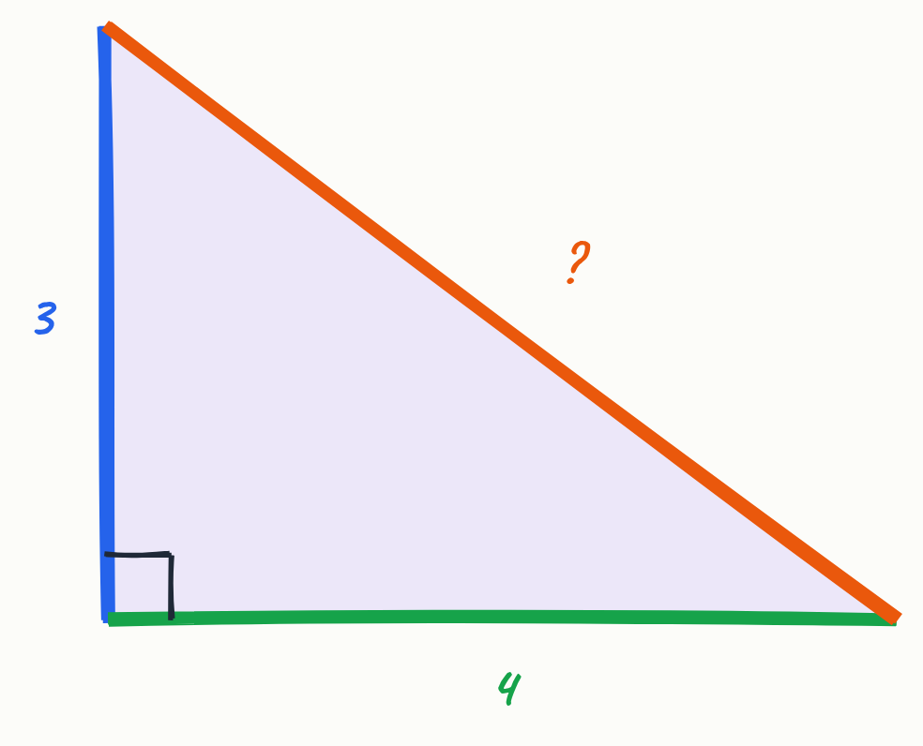
- Leg a (vertical) and leg b (horizontal) form the right angle
- Hypotenuse c is the longest side, opposite the right angle
- Example: legs of 3 and 4 units

Key terms
Right triangle | A triangle with one angle of exactly 90 degrees
Hypotenuse | The longest side of a right triangle, always opposite the right angle
Legs | The two shorter sides of a right triangle that form the right angle

2. The Pythagorean Formula and Square Areas
When you build a square on each side of a right triangle, the areas of these squares follow a special pattern. The square built on leg a has area a², the square on leg b has area b², and the square on the hypotenuse has area c². The key discovery is that the two smaller squares always add up exactly to the largest square.
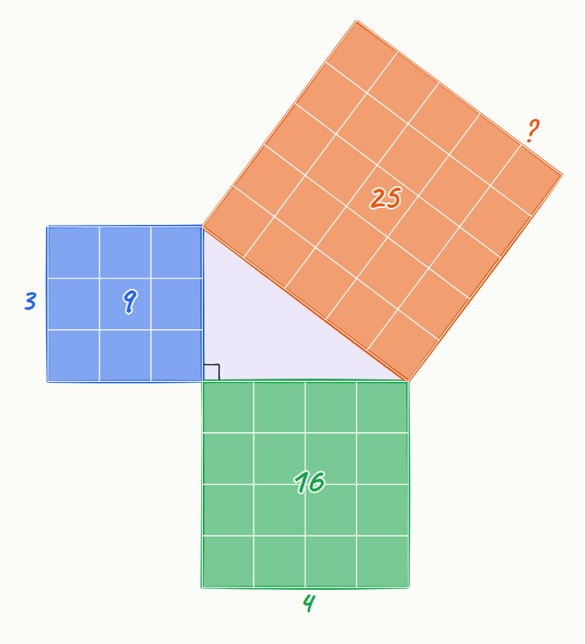
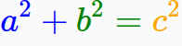
- Square on leg a has area a² (9 square units in our example)
- Square on leg b has area b² (16 square units in our example)
- Square on hypotenuse c has area c² (25 square units in our example)
- The formula: a² + b² = c²

Key terms
Pythagorean theorem | The relationship a² + b² = c² that holds for all right triangles

3. Solving for the Hypotenuse: Step-by-Step Method
To find a missing side, substitute the known values into the formula and solve. Start by squaring each leg, add the results, then take the square root. This three-step process—square, add, root—must be done in order. For legs 3 and 4: 3² + 4² = 9 + 16 = 25, so c = √25 = 5.
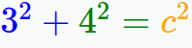
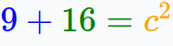
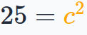
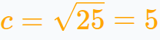
- Substitute known values: 3² + 4² = c²
- Square each leg: 9 + 16 = c²
- Add the squares: 25 = c²
- Take the square root: c = 5

4. Why Pythagoras' Theorem Works: Visual Proof
The theorem can be proven by rearranging four identical right triangles around a square. In one arrangement, the triangles surround a tilted square with area c². When you slide the same triangles into a different arrangement, they surround two separate squares with areas a² and b². Since the triangles are identical in both cases, the empty space (the gaps) must be equal, proving that a² + b² = c².
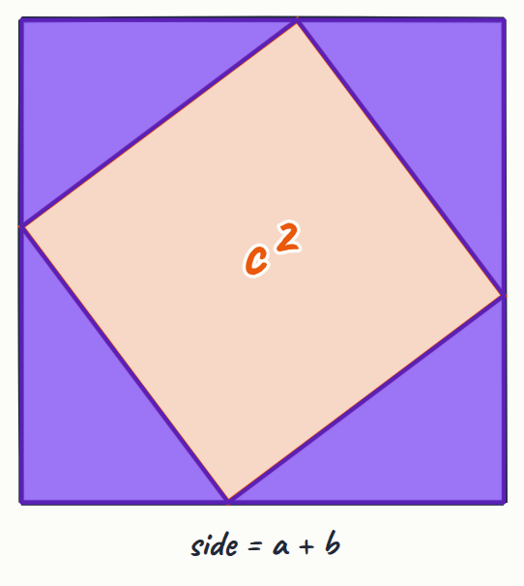
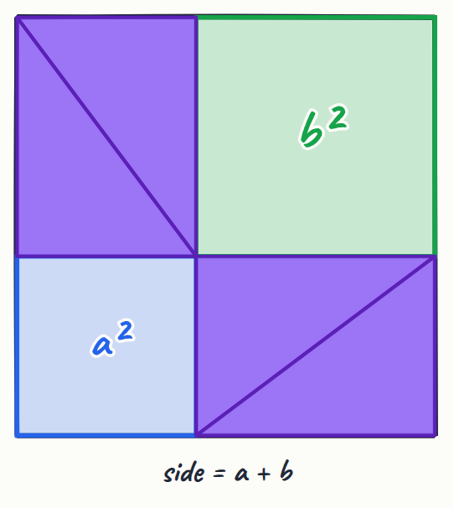
- Four identical triangles can be arranged two different ways
- First arrangement: triangles surround a square of area c²
- Second arrangement: triangles surround squares of areas a² and b²
- Equal gaps prove a² + b² = c²

5. Common Mistakes to Avoid
The most frequent error is adding the side lengths directly instead of squaring them first. For example, 3 + 4 = 7, but this is wrong—the hypotenuse is 5, not 7. Always remember the correct order: square each leg first, add those squares, then take the square root of the result.
- Wrong: a + b = c (gives 3 + 4 = 7, incorrect)
- Right: a² + b² = c² (gives 9 + 16 = 25, so c = 5)
- Always follow the order: Square → Add → Root

6. Real-World Applications
Pythagoras' theorem appears in many practical situations. A common example is a ladder leaning against a wall, which forms a right triangle. If the wall height is 6 metres and the distance from the wall base to the ladder base is 8 metres, the ladder length is 10 metres (since 6² + 8² = 36 + 64 = 100, and √100 = 10).
- Ladder against a wall creates a right triangle
- Wall height (6 m) and ground distance (8 m) are the legs
- Ladder length is the hypotenuse: 6² + 8² = 100, so c = 10 m

7. Summary and Key Takeaway
Pythagoras' theorem (a² + b² = c²) is a universal rule for right triangles. It allows you to find any missing side when you know the other two. The pattern holds because the areas of the squares on the two legs always add up exactly to the area of the square on the hypotenuse.
- Use a² + b² = c² to find missing sides
- Always square, add, then take the square root
- The theorem applies to every right triangle

Key points
- Pythagoras' theorem states a² + b² = c² for any right triangle, where a and b are legs and c is the hypotenuse
- The two smaller squares (on the legs) always add up exactly to the largest square (on the hypotenuse)
- To solve: substitute known values, square each leg, add the squares, then take the square root
- Common mistake: adding side lengths directly instead of squaring them first
- The theorem has practical uses in construction, navigation, and engineering
- The visual proof shows that rearranging four identical triangles proves the relationship must hold

Summary
Pythagoras' theorem (a² + b² = c²) is a fundamental rule stating that in any right triangle, the sum of the squares of the two legs equals the square of the hypotenuse. To find a missing side, substitute the known values, square each leg, add them together, and take the square root of the result. The theorem is proven by showing that four identical triangles can be arranged in two ways that create equal gaps, confirming the relationship always holds. This powerful tool is used in real-world applications from construction to navigation.

Practice questions
1. A right triangle has legs of 5 cm and 12 cm. Find the hypotenuse.
______________________________________________________________________
2. A ladder is 13 metres long and leans against a wall 5 metres high. How far is the base of the ladder from the wall?
______________________________________________________________________
3. What is wrong with saying that a 3-4-5 triangle has sides that add to 12?
______________________________________________________________________
4. A right triangle has legs of 8 m and 15 m. Calculate the hypotenuse to the nearest metre.
______________________________________________________________________
5. Explain why you must square the legs before adding them in Pythagoras' theorem.
______________________________________________________________________

Quick quiz
1. A right triangle has legs a = 5 and b = 12. What is the hypotenuse c?
(a) c = 17
(b) c = 13
(c) c = 11
(d) c = 15

Answer key

Practice questions
1. 5² + 12² = 25 + 144 = 169, so c = √169 = 13 cm
2. 5² + b² = 13², so 25 + b² = 169, giving b² = 144, and b = 12 metres
3. While 3 + 4 + 5 = 12 is true, Pythagoras' theorem uses squares: 3² + 4² = 9 + 16 = 25 = 5², not addition of the sides
4. 8² + 15² = 64 + 225 = 289, so c = √289 = 17 m
5. The theorem relates the areas of squares built on each side, not the side lengths themselves. Squaring converts side length to area, which is why we square first, add, then take the square root to return to length

Quick quiz
1. (b) c = 13 — 5² + 12² = 25 + 144 = 169, and √169 = 13.

