STUDY NOTES

How Does Photosynthesis Work?
Simple
Photosynthesis is the process by which plants turn sunlight, water and carbon dioxide into food and oxygen. This lesson explains how leaves capture light energy and use it to build sugar, which feeds the plant and produces the oxygen we breathe.

1. What is Photosynthesis?
Plants are like tiny solar panels that capture energy from the Sun. A plant leaf contains millions of cells that work together to turn light energy into chemical energy stored in food.
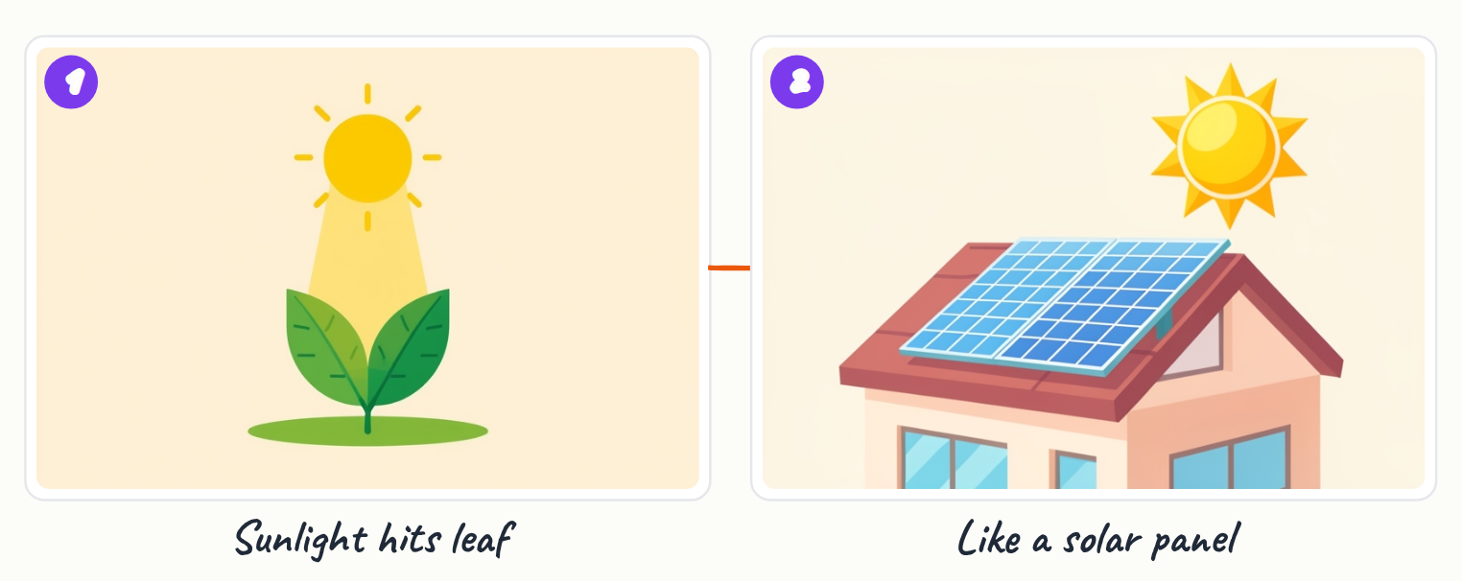
- Plants turn sunlight into food through photosynthesis
- Leaves act like solar panels to capture light energy from the Sun

2. Chlorophyll: The Light Catcher
Inside leaves are millions of cells packed with a green pigment called chlorophyll. This pigment absorbs light energy, especially red and blue wavelengths. When chlorophyll captures this energy, it splits water molecules into hydrogen and oxygen. The oxygen is released into the air as a waste product that we breathe.
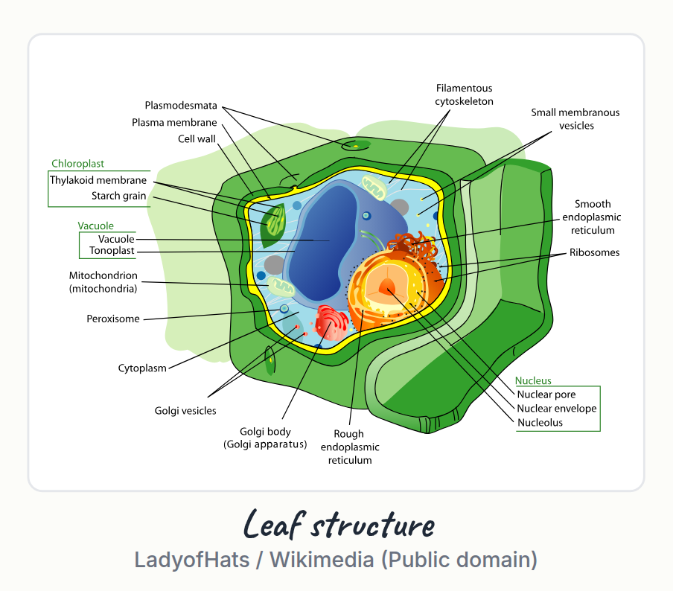
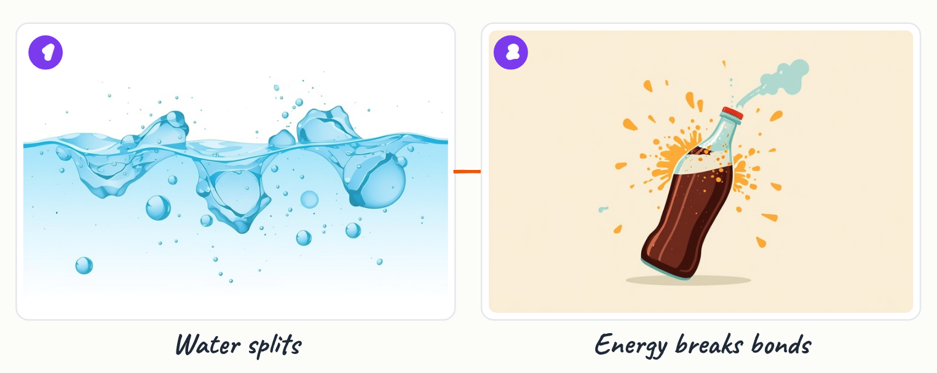
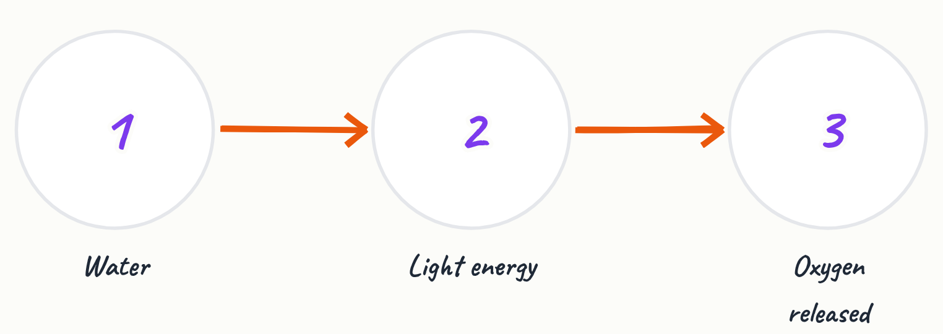
- Chlorophyll is the green pigment that absorbs light energy
- It absorbs red and blue wavelengths most effectively
- Splitting water molecules releases oxygen as waste

Key terms
Chlorophyll | The green pigment in plant cells that captures light energy from the Sun

3. Building Sugar: The Energy Store
The energy captured by chlorophyll is used to build sugar. The plant takes carbon dioxide from the air and combines it with the captured energy to create glucose, a simple sugar. Glucose stores chemical energy in its molecular bonds. The plant then uses this glucose to grow, build leaves and roots, and make seeds.
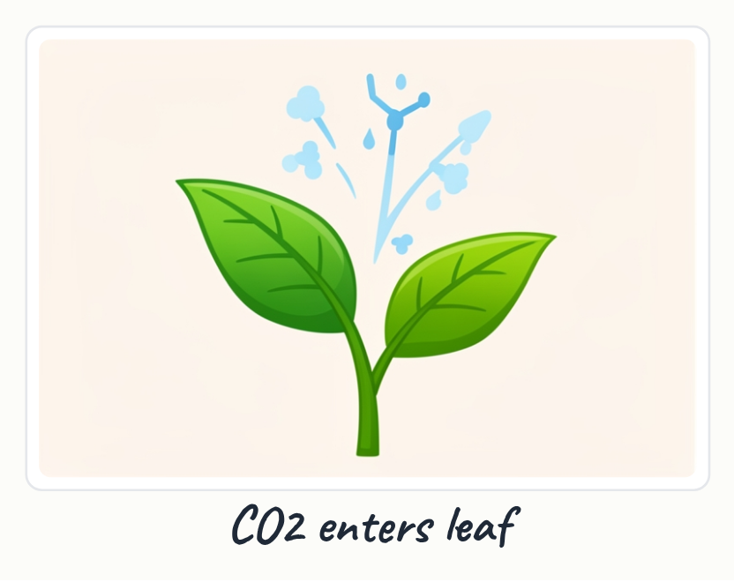
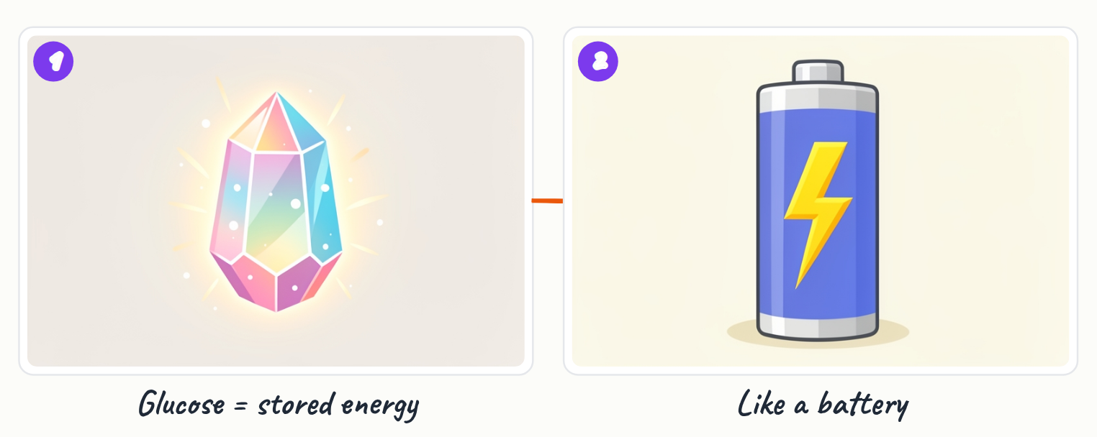

- Energy is captured and stored in sugar bonds
- Carbon dioxide from air is turned into glucose (simple sugar)
- Glucose provides energy for the plant to grow and reproduce

Key terms
Glucose | A simple sugar that stores chemical energy and serves as food for the plant

4. The Complete Photosynthesis Equation
The entire photosynthesis process can be shown as one equation. Six water molecules plus six carbon dioxide molecules, powered by light energy, produce one glucose molecule and six oxygen molecules. This equation shows exactly what goes in and what comes out.
- 6H₂O + 6CO₂ + light energy → C₆H₁₂O₆ + 6O₂
- Water and carbon dioxide are the raw materials
- Glucose and oxygen are the products

5. Photosynthesis in Real Life
Photosynthesis happens in plants all around us every day. A tomato plant in a garden absorbs sunlight and builds sugars that make the tomato sweet and red. This same process occurs in every plant on Earth.
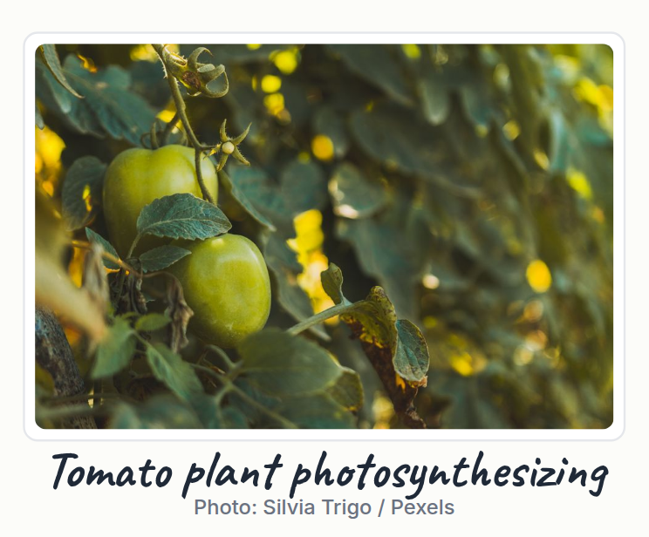
- Tomato plants use photosynthesis to make sweet, red tomatoes
- Photosynthesis happens continuously in plants exposed to sunlight

6. Why Photosynthesis Matters
Photosynthesis is essential for all life on Earth. Without it, there would be no oxygen for us to breathe and no food for any animal. Plants use photosynthesis to convert light, water and carbon dioxide into glucose and oxygen, supporting every living thing on the planet.
- Photosynthesis produces the oxygen we breathe
- It is the foundation of all food chains on Earth
- Without photosynthesis, life as we know it could not exist

Key points
- Photosynthesis is how plants turn sunlight, water and carbon dioxide into glucose (food) and oxygen
- Chlorophyll is the green pigment in leaves that captures light energy from the Sun
- Light energy is used to split water molecules and build sugar molecules
- The complete equation is: 6H₂O + 6CO₂ + light energy → C₆H₁₂O₆ + 6O₂
- Plants use glucose to grow, build leaves and roots, and make seeds
- Photosynthesis produces oxygen for us to breathe and is the foundation of all life on Earth

Summary
Photosynthesis is the process by which plants capture sunlight and convert it into food. Chlorophyll in plant leaves absorbs light energy and uses it to split water molecules and combine carbon dioxide into glucose sugar. This glucose stores energy that the plant uses to grow, and oxygen is released as a waste product. Photosynthesis is essential for all life on Earth because it produces the oxygen we breathe and forms the base of all food chains.

Practice questions
1. What is the green pigment in leaves that captures light energy?
______________________________________________________________________
2. What two things does a plant need from its environment to perform photosynthesis?
______________________________________________________________________
3. What is glucose and why is it important to the plant?
______________________________________________________________________
4. Write the photosynthesis equation and explain what each part means.
______________________________________________________________________
5. Why is photosynthesis important for all life on Earth?
______________________________________________________________________

Quick quiz
1. What pigment captures light in leaves?
(a) Carotene
(b) Chlorophyll
(c) Hemoglobin

Answer key

Practice questions
1. Chlorophyll is the green pigment that absorbs light energy, especially red and blue wavelengths.
2. A plant needs water (from soil) and carbon dioxide (from air), plus sunlight energy.
3. Glucose is a simple sugar that stores chemical energy. The plant uses it as food to grow, build leaves and roots, and make seeds.
4. 6H₂O + 6CO₂ + light energy → C₆H₁₂O₆ + 6O₂. Six water molecules and six carbon dioxide molecules, powered by light energy, produce one glucose molecule and six oxygen molecules.
5. Photosynthesis produces oxygen for us to breathe and creates glucose that feeds plants and all animals that eat plants, forming the base of all food chains.

Quick quiz
1. (b) Chlorophyll — Chlorophyll is the green pigment that absorbs light energy in plant cells.

