STUDY NOTES

Why Do Volcanoes Erupt?
Class 9-10
Volcanoes erupt when pressure from hot, expanding gases inside magma chambers forces molten rock to the surface. The type of eruption depends on where the volcano forms and the properties of the magma, which determines how easily gases can escape.

1. Magma Formation and Pressure Build-Up
Deep underground, Earth's extreme heat melts rock into magma, which collects in chambers beneath the crust. As magma heats up, dissolved gases—mainly water, carbon dioxide, and sulfur—expand and push harder against the surrounding rock. This pressure builds until the rock can no longer hold it back, causing cracks to form. When the pressure becomes too strong, magma rushes up through these cracks, reaches the surface, and erupts as lava, ash, and gas.
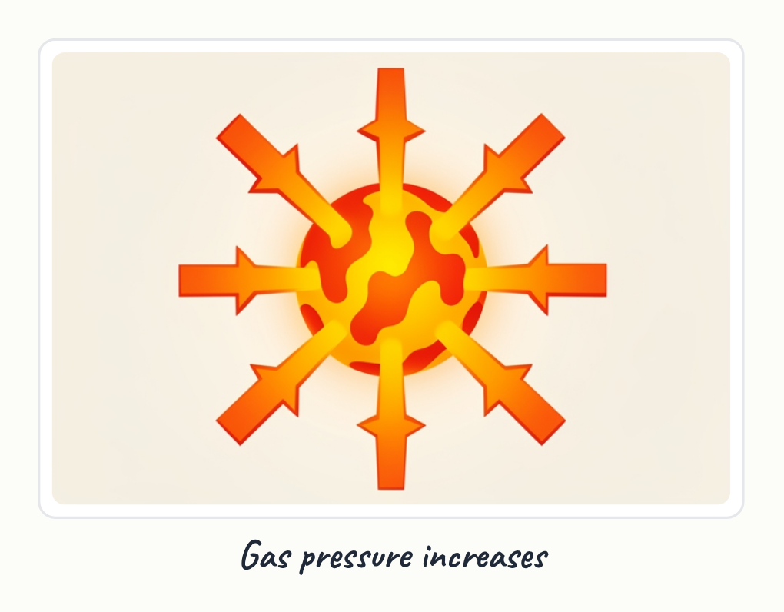
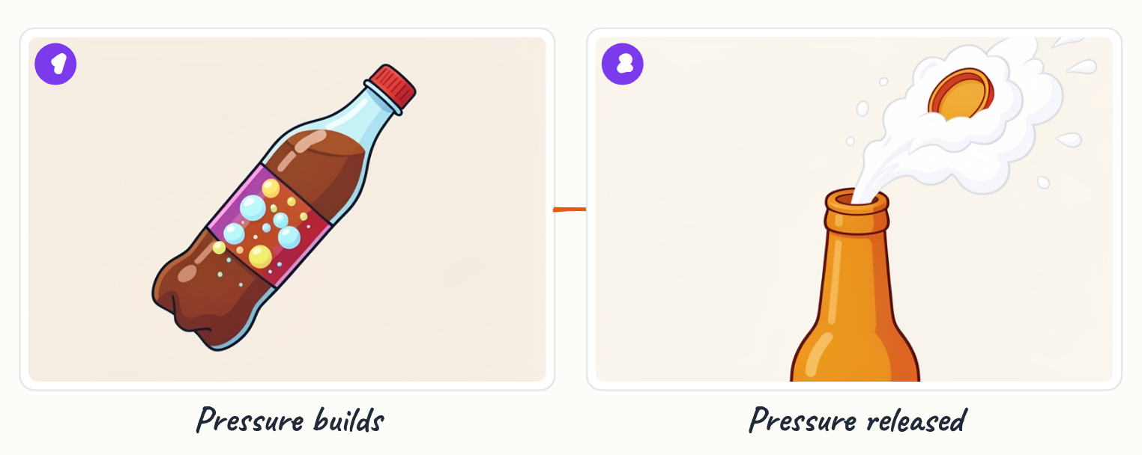
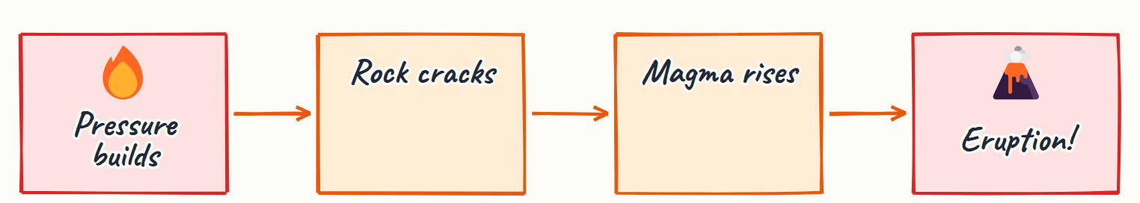
- Magma forms in chambers deep underground where rock melts from extreme heat
- Dissolved gases expand as magma heats, creating pressure against the rock above
- Pressure builds until rock fractures, similar to a lid popping off a shaken soda bottle
- Magma erupts through cracks as lava, ash, and gas

Key terms
Magma | molten rock beneath Earth's surface
Lava | magma that has reached Earth's surface
Pressure | force pushing outward from expanding gases and heat

2. Mid-Ocean Ridge Volcanoes: Gentle Eruptions
At mid-ocean ridges, tectonic plates pull apart, and hot magma rises to fill the gap between them. This magma is thin and runny, allowing dissolved gases to escape easily as it rises. Because gases are not trapped, eruptions at mid-ocean ridges are gentle and steady rather than explosive.
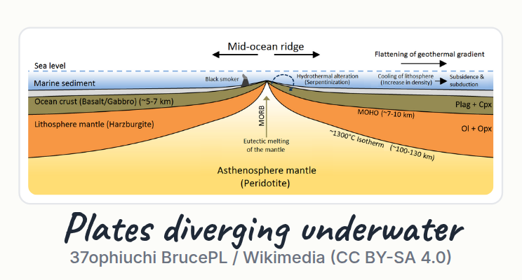
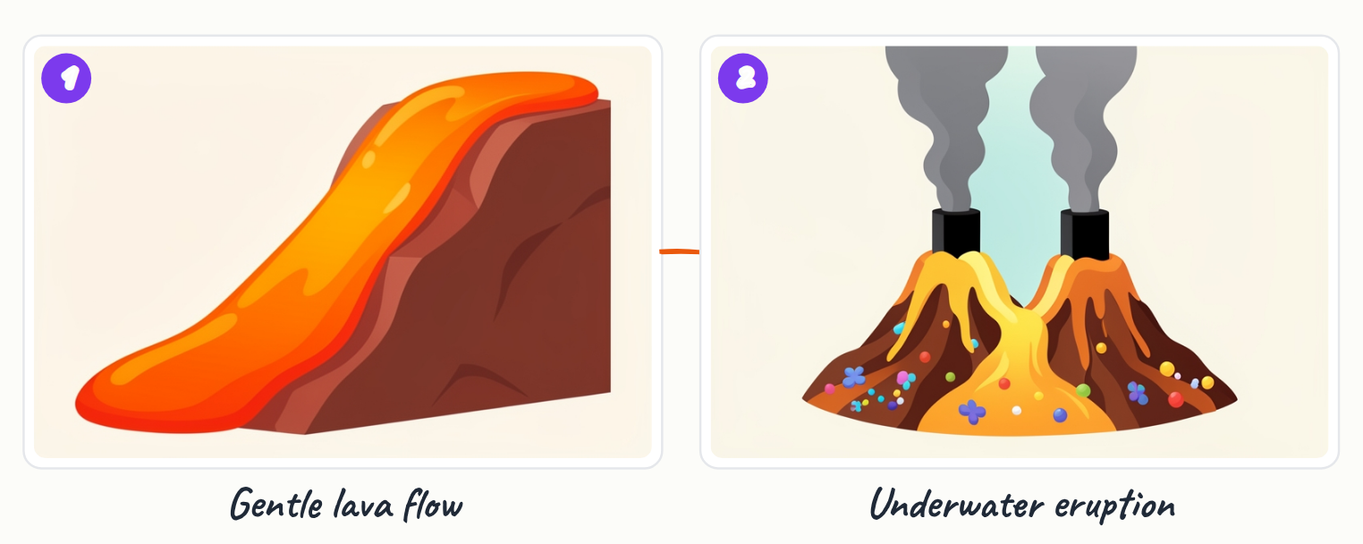
- Mid-ocean ridges form where tectonic plates pull apart
- Magma at ridges is thin and runny, letting gases escape freely
- Gentle, steady eruptions occur because pressure does not build up

Key terms
Mid-ocean ridge | underwater mountain range where tectonic plates separate and new crust forms

3. Why Eruption Style Varies
Not all volcanoes erupt the same way because eruption style depends on two key factors: the location where the volcano forms and the type of magma present. Thin, runny magma allows gases to escape, producing gentle eruptions, while thick, sticky magma traps gases and causes explosive eruptions.
- Location determines magma type and eruption style
- Thin magma = gentle eruptions; thick magma = explosive eruptions
- Gas escape is the key difference between eruption types

4. Subduction Zone Volcanoes: Explosive Eruptions
At the Pacific Ring of Fire and other subduction zones, tectonic plates collide and one plate slides beneath another in a process called subduction. The sinking plate melts deep underground, creating thick, sticky magma that traps gases inside like a pressure cooker. When pressure finally becomes too great, gases explode violently, sending ash and rock high into the air.
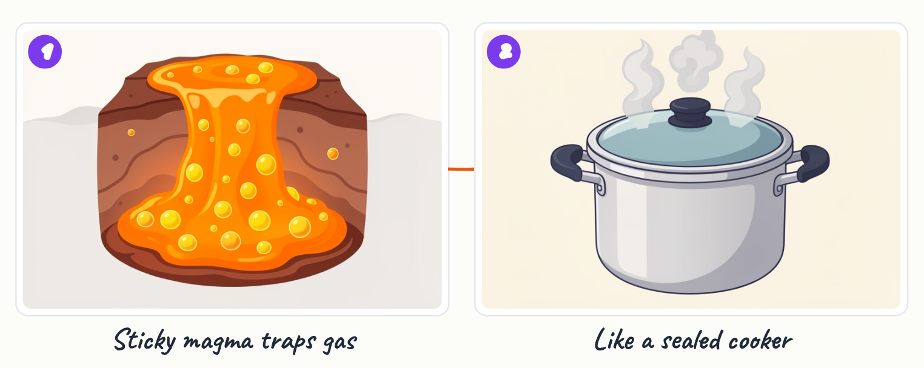
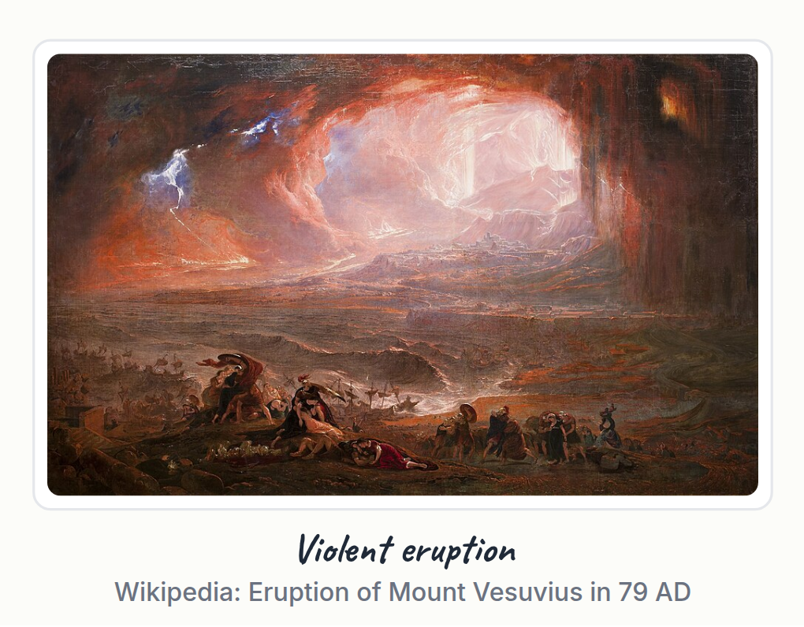
- Subduction occurs when one tectonic plate slides under another at collision zones
- Thick, sticky magma traps gases and prevents them from escaping easily
- Pressure builds to extreme levels before erupting explosively
- Explosive eruptions send ash and rock high into the atmosphere

Key terms
Subduction | process where one tectonic plate slides beneath another into the mantle
Ring of Fire | region around the Pacific Ocean where many subduction zones and volcanoes occur

5. Hotspot Volcanoes: Island Chains
Some volcanoes form over hotspots, where a plume of exceptionally hot rock rises from deep within Earth's mantle and melts the crust above. As tectonic plates move over these stationary hotspots, they create chains of volcanoes. The Hawaiian Islands are a classic example, formed as the Pacific plate moved over a hotspot, leaving a trail of extinct and active volcanoes.

- Hotspots are stationary plumes of hot rock rising from Earth's mantle
- Hotspots melt the crust above, creating volcanoes
- As plates move over hotspots, chains of volcanoes form over time
- The Hawaiian Islands were created by the Pacific plate moving over a hotspot

Key terms
Hotspot | a stationary region of intense heat in Earth's mantle that melts the crust above

Key points
- Volcanoes erupt when pressure from expanding, trapped gases forces magma up through cracks in Earth's crust.
- Magma contains dissolved gases—water, carbon dioxide, and sulfur—that expand as temperature increases.
- Mid-ocean ridge volcanoes have thin, runny magma that lets gases escape, causing gentle eruptions.
- Subduction zone volcanoes have thick, sticky magma that traps gases, causing explosive eruptions.
- Hotspot volcanoes form over stationary plumes of hot rock and create chains of islands as plates move.
- Eruption style depends on magma type and location, not just the presence of magma alone.

Summary
Volcanoes erupt because pressure from expanding gases in magma chambers becomes too strong for the surrounding rock to contain, forcing magma to the surface. The type of eruption—gentle or explosive—depends on magma thickness and gas escape: thin magma at mid-ocean ridges produces steady eruptions, while thick magma at subduction zones traps gases and causes violent explosions. Hotspot volcanoes form over stationary heat plumes and create island chains as tectonic plates move. Understanding these mechanisms explains why different volcanoes behave differently.

Practice questions
1. What role do dissolved gases play in causing a volcanic eruption?
______________________________________________________________________
2. Why are eruptions at mid-ocean ridges gentler than eruptions at subduction zones?
______________________________________________________________________
3. Explain how the Hawaiian Islands were formed using the concept of a hotspot.
______________________________________________________________________
4. What is subduction, and how does it lead to explosive volcanic eruptions?
______________________________________________________________________
5. Why does magma behave like a shaken soda bottle before erupting?
______________________________________________________________________

Quick quiz
1. Why do subduction zone volcanoes erupt explosively?
(a) Runny magma lets gases escape slowly
(b) Thick magma traps gases, building pressure
(c) The plates move faster underground
(d) Hotspots are deeper than ridges

Answer key

Practice questions
1. Dissolved gases (water, carbon dioxide, sulfur) expand as magma heats up, creating pressure that pushes against the rock above. When pressure becomes too strong, it cracks the rock and forces magma to the surface.
2. Mid-ocean ridge magma is thin and runny, allowing gases to escape easily, so pressure does not build up. Subduction zone magma is thick and sticky, trapping gases like a pressure cooker, causing pressure to build and erupt explosively.
3. The Hawaiian Islands formed as the Pacific tectonic plate moved over a stationary hotspot in Earth's mantle. The hotspot melted the crust above, creating volcanoes. As the plate continued to move, the hotspot left behind a chain of extinct volcanoes, forming the island chain.
4. Subduction is the process where one tectonic plate slides beneath another at collision zones. The sinking plate melts deep underground, creating thick, sticky magma that traps gases. Pressure builds until it explodes violently, causing explosive eruptions.
5. Both contain pressurized gas trapped inside a container. In a soda bottle, carbonation creates pressure; in magma, expanding dissolved gases create pressure. When pressure becomes too great, the seal breaks—the bottle cap pops off, and magma erupts through cracks in the rock.

Quick quiz
1. (b) Thick magma traps gases, building pressure — Thick magma at subduction zones traps gases, creating a pressure cooker effect.

