STUDY NOTES

Rotation (Ghoomna) - Basic Samajh
Simple · Hinglish (Hindi + English)
Is lesson mein hum rotation ka matlab samjhenge, yaani kisi cheez ka ek fixed centre ke around ghoomna. Chakkar aur degrees ka relation samajhna bahut zaroori hai kyunki angles aur rotation ke sawaal isi par based hote hain.

1. Rotation kya hai
Rotation ka matlab hai koi cheez ek fixed point ya line ke around ghoomti hai. Lattu ya fidget spinner isi ke examples hain. Jis fixed point ke around cheez ghoomti hai, use centre kehte hain.
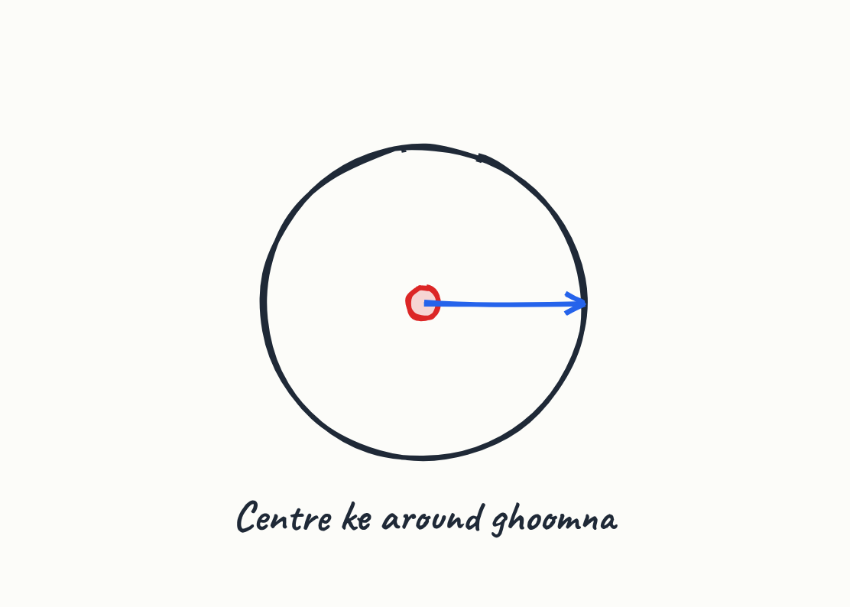
- Rotation mein ek fixed centre hota hai.
- Poori cheez isi centre ke around ghoomti hai.

Shabd
Rotation | Kisi fixed point ya line ke around ghoomna.
Centre | Woh fixed point jiske around cheez ghoomti hai.

2. Chakkar aur degrees
Jab radius ek circle mein ghoomta hai, toh ek poora chakkar banta hai. Ek poora chakkar 360 degrees ka hota hai, aur aadha chakkar 180 degrees ka.
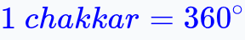
- 1 chakkar = 360 degrees
- Aadha chakkar = 180 degrees

Shabd
Radius | Centre se circle ke kinare tak ki seedhi line.
Degree | Angle naapne ki ikai; ek poora chakkar 360 degrees hota hai.

3. Unit circle par chakkar ke hisse
Unit circle par radius zero degrees se shuru hokar ghoomta hai. Alag-alag angles par radius ki position badalti hai aur 360 degrees par woh wapas shuruwat par aa jaata hai.
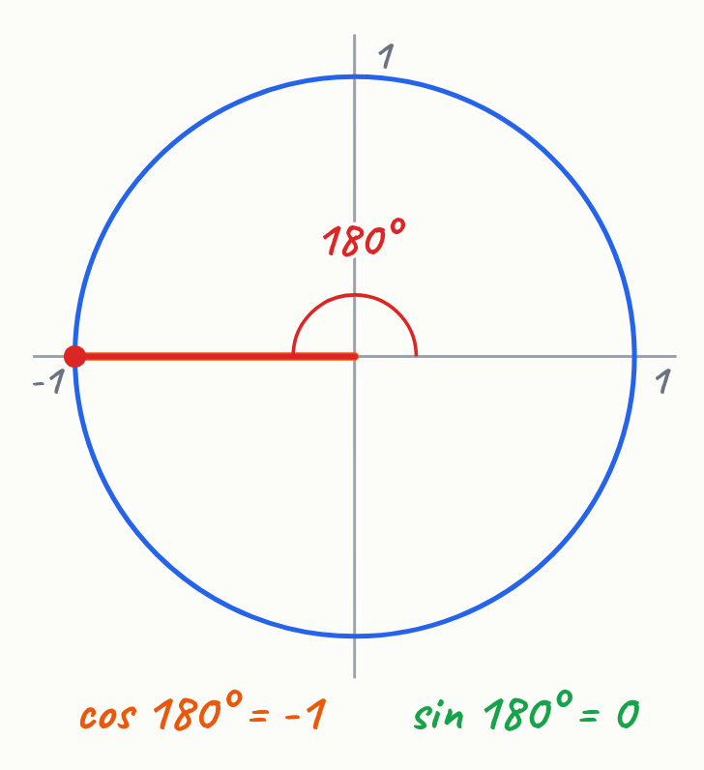
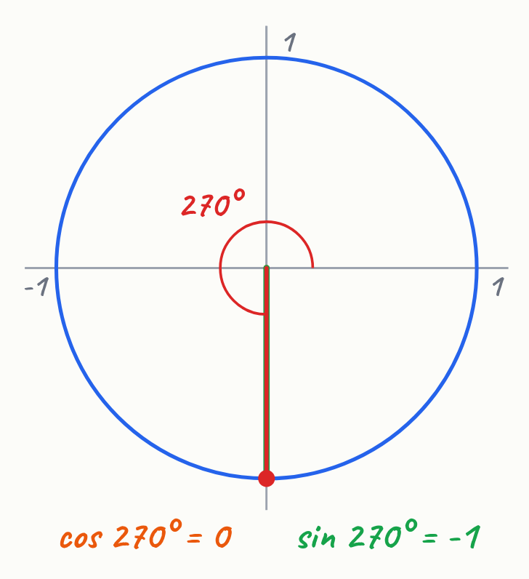
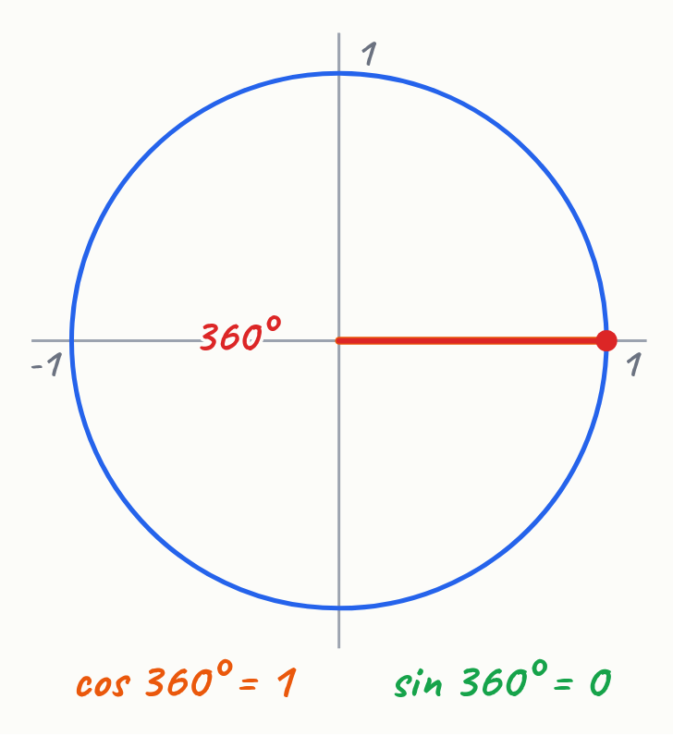
- 90 degrees = 1/4 chakkar (chauthai chakkar)
- 180 degrees = 1/2 chakkar (aadha chakkar)
- 270 degrees = 3/4 chakkar
- 360 degrees = poora chakkar, shuruwat par wapas

4. Chakkar ka hisaab lagana
Poore chakkar ke 360 degrees ko divide karke kisi bhi hisse ka angle nikaal sakte hain. Aadhe chakkar ke liye 360 ko 2 se divide karte hain, aur chauthai chakkar ke liye 360 ko 4 se.
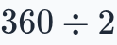
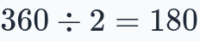
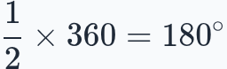
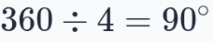
- Aadha chakkar: 360 ÷ 2 = 180 degrees
- Chauthai chakkar: 360 ÷ 4 = 90 degrees
- Hisaab ka tareeka: fraction × 360 degrees

5. Rotation ke important points
Rotation ko samajhne ke liye centre aur angle dono zaroori hain, kyunki bina centre ke ghoomna possible nahi. Ghoomne se cheez ka size nahi badalta, sirf uski direction ya position badalti hai.
- Rotation = centre + angle
- Ghoomne se size same rehta hai
- Galti se size badalne ka soch-na sahi nahi hai

6. Real life mein rotation: Pulsar
Pulsar space mein ek tez ghoomta hua neutron star hai jo lighthouse ki tarah kaam karta hai. Uski beam jab Earth ki taraf aati hai, toh hume pulse dikhta hai.
- Pulsar ek neutron star hai
- Woh lighthouse ki tarah beam chhodta hai
- Regular rotation ki wajah se pulses ke beech ka time precise hota hai

Shabd
Pulsar | Tez ghoomta hua neutron star jo regular pulses bhejta hai.

Mukhya Baatein
- Rotation ka matlab hai centre ke around ghoomna.
- 1 poora chakkar = 360 degrees.
- Aadha chakkar = 180 degrees, chauthai chakkar = 90 degrees.
- Angle nikaalne ke liye fraction ko 360 degrees se multiply karte hain.
- Rotation mein centre aur angle dono zaroori hain.
- Ghoomne se cheez ka size nahi badalta.

Saraansh
Rotation ka matlab hai kisi cheez ka ek fixed centre ke around ghoomna. Ek poora chakkar 360 degrees ka hota hai, aur usi se aadha (180 degrees), chauthai (90 degrees) jaise hisson ke angles nikalte hain. Yeh idea space ke pulsar jaise real-life examples mein bhi dikhta hai.

Abhyaas Sawaal
1. Ek poora chakkar kitne degrees ka hota hai?
______________________________________________________________________
2. Teen chauthai chakkar kitne degrees ke hote hain?
______________________________________________________________________
3. Rotation ke liye kaun si do cheezein zaroori hain?
______________________________________________________________________
4. Agar ek cheez 180 degrees ghoomti hai, toh woh kitna chakkar hua?
______________________________________________________________________
5. Kya rotation se cheez ka size badal jaata hai?
______________________________________________________________________

Quick quiz
1. Ek poore chakkar mein kitne degrees hote hain?
(a) 180
(b) 360
(c) 90

Jawab

Abhyaas Sawaal
1. Ek poora chakkar 360 degrees ka hota hai.
2. Teen chauthai chakkar = 3/4 × 360 = 270 degrees.
3. Ek fixed centre aur ghoomne ka angle.
4. 180 degrees = aadha chakkar (1/2 chakkar).
5. Nahi, rotation se cheez ka size same rehta hai.

Quick quiz
1. (b) 360 — Ek poora chakkar teen sau saath degrees ka hota hai.

