STUDY NOTES

How Light Works
Simple
This lesson explains what light is, how it travels, and how it lets us see objects. Understanding these basics helps explain everyday things like mirrors, bent-looking pencils, and rainbows.

1. What light is and how fast it travels
Light is energy that travels outward from things that glow, such as the Sun, a flame, or a light bulb. It moves in straight lines, spreading out in every direction from its source. Light is extremely fast, so even sunlight takes only about eight minutes to reach us from the Sun.
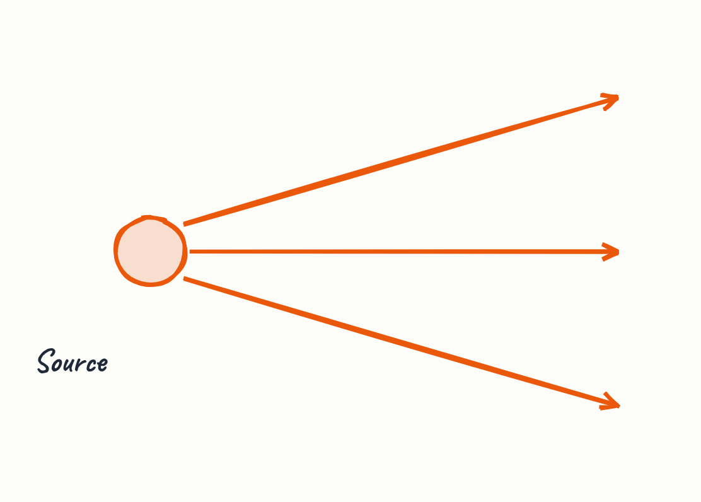
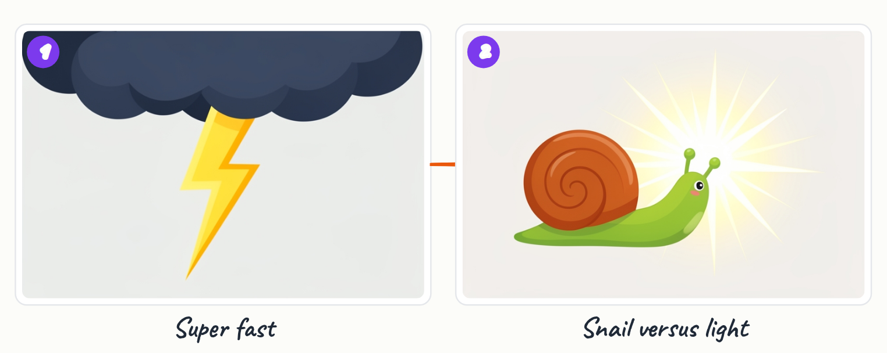

- Light is energy given off by glowing objects.
- Light travels in straight lines in all directions from its source.
- Light travels at about 300,000 kilometres every second.

Key terms
Light source | An object that gives off its own light, such as the Sun, a flame, or a bulb.

2. How we see objects
We do not see objects by looking at them directly; we see them when light bounces off them and then enters our eyes. Smooth, shiny surfaces reflect light in an orderly way, which is why a mirror shows a clear picture.
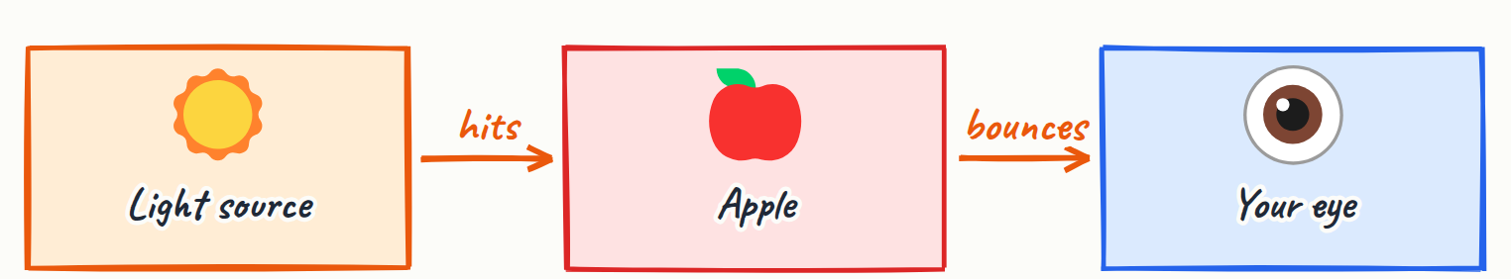
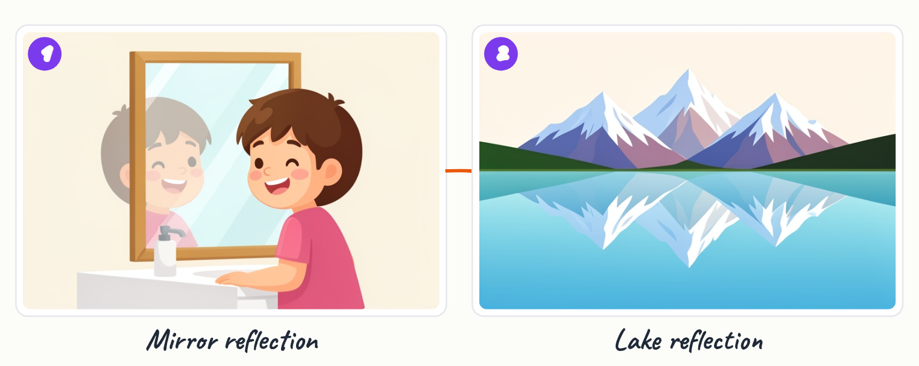
- Light must bounce off an object and reach the eye for us to see it.
- Smooth shiny surfaces reflect light neatly, as in a mirror.

Key terms
Reflection | When light bounces off a surface.

3. Bending of light and refraction
When light passes from one material into another, such as air into water or glass, it changes direction. This bending is called refraction. It is why a pencil standing in water looks bent.
- Light bends when it passes into water or glass.
- A pencil placed in water appears bent.

Key terms
Refraction | The bending of light as it passes into a different material.

4. Colours of light and rainbows
Sunlight looks white, but it is actually a mixture of many colours. Raindrops act like tiny prisms, separating sunlight into the colours of a rainbow. Each colour corresponds to a different wavelength, with red having the longest wave and violet the shortest.
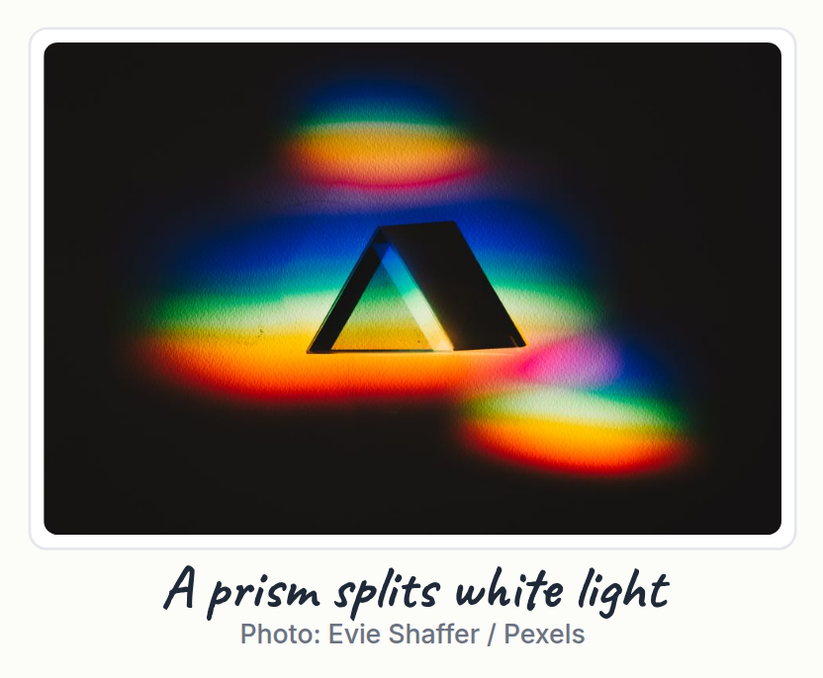

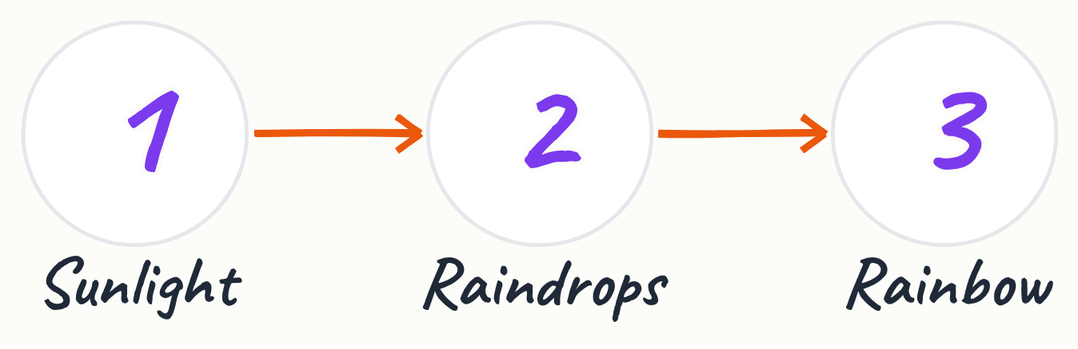
- White sunlight contains many colours.
- Raindrops split sunlight into a rainbow.
- Red has the longest wavelength; violet has the shortest.

Key terms
Wavelength | The distance between one peak of a light wave and the next; it determines the colour.

5. Why objects have colour
An object's colour depends on which light it reflects. A red apple reflects red light to your eyes and absorbs most of the other colours, so it appears red.
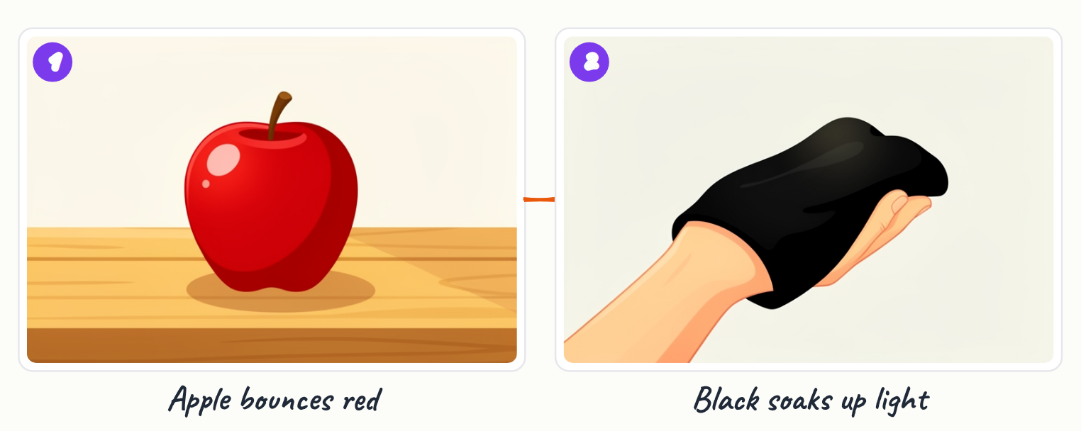
- Objects reflect some colours and absorb the rest.
- The reflected colour is the one we see.

Key terms
Absorb | When a surface takes in light instead of reflecting it.

6. Wave and particle nature, and invisible light
Light behaves both like a wave and like tiny packets of energy called photons. Our eyes detect only a small part of the light spectrum. Other forms, such as radio waves and X-rays, are invisible to us.

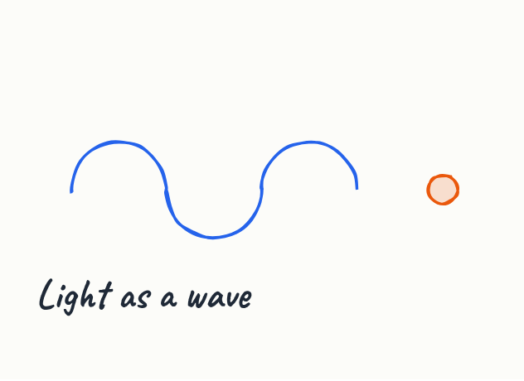
- Light acts as a wave and as photons.
- Humans can only see a small slice of light.
- Radio waves and X-rays are types of light we cannot see.

Key terms
Photon | A tiny packet of light energy.

Key points
- Light is energy from glowing objects and travels in straight lines at about 300,000 km per second.
- We see objects when light bounces off them and enters our eyes.
- Light bends (refraction) when it passes into water or glass.
- White sunlight is a mix of colours, each with a different wavelength.
- An object looks red because it reflects red light and absorbs other colours.

Summary
Light is energy that travels fast in straight lines from glowing sources. We see the world because light bounces off objects into our eyes. Along the way, light can bend, as in refraction, and split into colours, as in rainbows. Understanding these ideas explains how vision and colour work.

Practice questions
1. Why can we see a red apple?
______________________________________________________________________
2. How long does sunlight take to reach Earth, and why does this matter?
______________________________________________________________________
3. What is refraction?
______________________________________________________________________
4. Which colour of light has the longest wavelength?
______________________________________________________________________
5. Why does a mirror show a clear picture while a rough surface does not?
______________________________________________________________________

Quick quiz
1. Why does a red apple look red?
(a) It makes its own red light
(b) It bounces red light to your eyes
(c) Red light cannot reach it

Answer key

Practice questions
1. The apple reflects red light into our eyes and absorbs most other colours, so light bouncing off it reaches us and we see red.
2. About eight minutes. Light travels so fast that this delay is short, but it shows light takes real time to travel across space.
3. Refraction is the bending of light when it passes from one material into another, such as air into water or glass.
4. Red has the longest wavelength, and violet has the shortest.
5. A smooth shiny surface reflects light neatly and in an orderly way, so the image stays clear; a rough surface scatters light in many directions.

Quick quiz
1. (b) It bounces red light to your eyes — It absorbs other colours and bounces red light into your eyes.

