STUDY NOTES

explain integeration
Class 9-10

1. Part 1
What if you could find the area under any curve — that is the magic of integration. Let us start by drawing a simple curve and the area we want to find beneath it. The shaded region between the curve and the x-axis is exactly what integration measures. Before integration, people tried to estimate this area using thin rectangles underneath the curve.
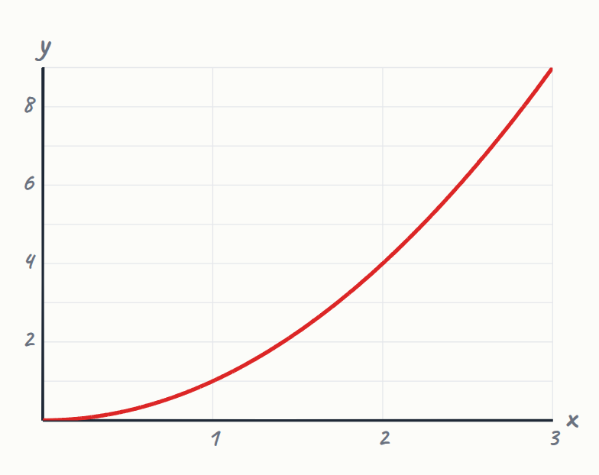

2. More rectangles → more accurate area
The more rectangles you use, the closer you get to the true area under the curve. Integration is the limit of this process — infinitely many infinitely thin rectangles. We write integration using this special elongated S symbol, called the integral sign. The integral sign means sum, x squared is the function, and d x means a tiny strip of width.
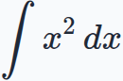
- Integration = limit of infinite rectangles
- dx = infinitely thin width strip

3. C = constant of integration (unknown shift)
The general power rule for integration says: raise the power by one, then divide by the new power. Here n is the original power, n plus one is the new power, and C is the constant of integration. Let us work through a simple example: integrate x squared with respect to x. The power is 2, so we add 1 to get 3, giving us x cubed on top.
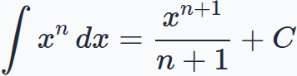
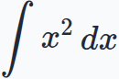
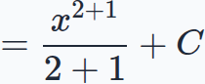

4. Part 4
Simplifying, two plus one is three, so the answer is x cubed over three plus C. Now let us find a definite integral — the actual area between x equals 1 and x equals 3. We substitute the limits: plug in 3 first, then subtract the result when we plug in 1. Three cubed is 27, so 27 over 3 is 9, and 1 over 3 stays as one third.
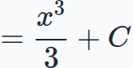
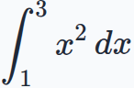
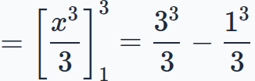
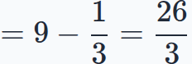

5. Area = 26/3 ≈ 8.67 sq units
So the exact area under x squared from 1 to 3 is twenty-six thirds, roughly 8.67 square units. A very common mistake: students forget to add C when there are no limits given. In real life, engineers use integration to find the distance a car travels from its speed-time graph. The area under the speed-time graph — found by integration — gives the total distance travelled.
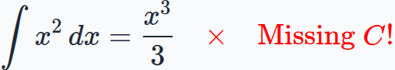
- Speed × Time = Distance = integral

6. ∫xⁿ dx = xⁿ⁺¹/(n+1) + C
Now your turn: what is the integral of x cubed with respect to x? Integration finds the area under a curve by summing infinite thin strips using the power rule.

Quick quiz
1. What is ∫ x³ dx ?
(a) x⁴ + C
(b) x⁴ / 4 + C
(c) 3x² + C
(d) x⁴ / 3 + C

Answer key

Quick quiz
1. (b) x⁴ / 4 + C — Add 1 to the power (3+1=4) then divide by the new power 4, giving x⁴/4 + C.

