STUDY NOTES

The Pythagorean Theorem: Why a² + b² = c² Holds
Deep dive
This lesson explains the Pythagorean theorem for right triangles, relating the squares built on the two legs to the square built on the hypotenuse. It matters because the same relationship underpins distance calculations, geometry proofs, and many practical measurements.

1. Right triangles and their parts
A right triangle has one angle of exactly ninety degrees. The two sides that meet at the right angle are the legs, and the side opposite the right angle is the hypotenuse, which is always the longest side because it faces the largest angle. The example used throughout has legs of length three and four.
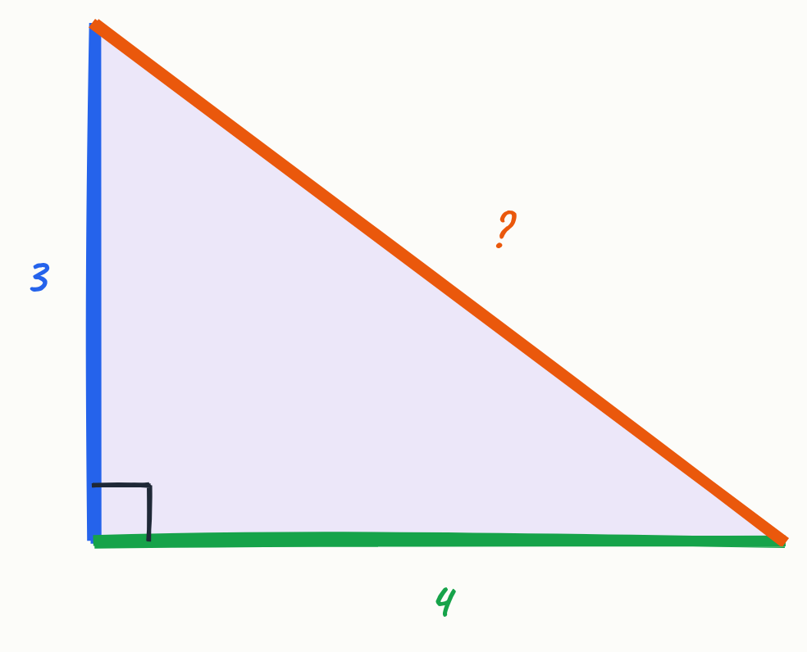
- Legs: the two sides forming the right angle (here 3 and 4)
- Hypotenuse: the side opposite the right angle, always the longest
- The hypotenuse faces the largest angle of the triangle

Key terms
Leg | One of the two sides that meet at the right angle of a right triangle.
Hypotenuse | The side opposite the right angle in a right triangle.

2. The theorem as a statement about area
The theorem is best understood as a relationship between areas rather than lengths. Building a unit-square grid on each side shows that the square on leg a has area 9, the square on leg b has area 16, and the square on the hypotenuse has area 25. The two smaller areas add up to the largest.
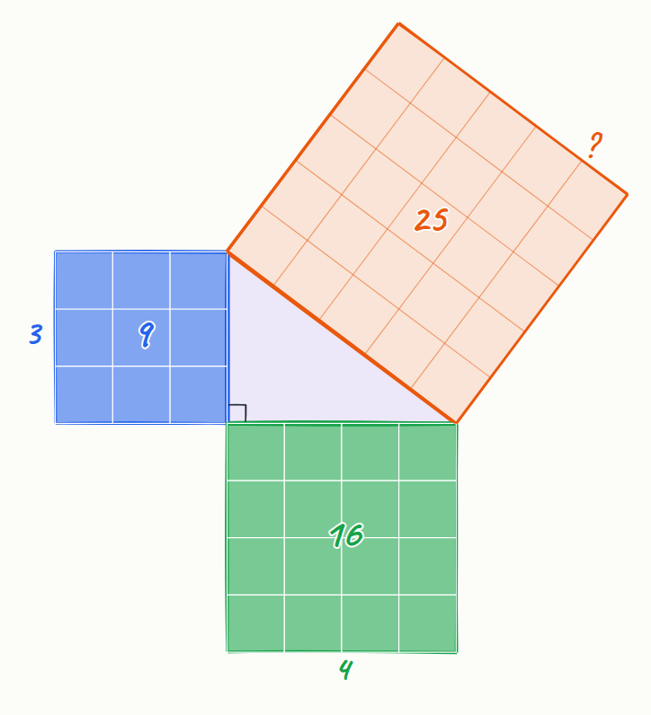
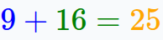
- Square on leg a (length 3): 9 unit squares
- Square on leg b (length 4): 16 unit squares
- Square on the hypotenuse (length 5): 25 unit squares
- The areas of the two leg squares together equal the hypotenuse square's area

3. The Pythagorean equation and its symbols
With side lengths a, b and c, where c is the hypotenuse, the theorem is written as a squared plus b squared equals c squared. Each symbol stands for a length, and squaring a length gives the area of the square built on that side.
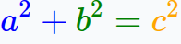
- a and b are the leg lengths; c is the hypotenuse length
- Squaring a length gives the area of the square on that side
- The colour coding (blue for a, green for b, orange for c) matches the three squares

Key terms
Square root | The non-negative number which, multiplied by itself, gives the original number.

4. Worked example: finding the hypotenuse
To find the hypotenuse when both legs are known, substitute the leg lengths into the equation, square each leg, add the results, and then take the square root. For legs of three and four, the sum is twenty-five, so the hypotenuse is five.
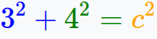
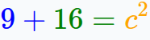
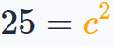
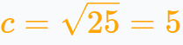
- Substitute: 3² + 4² = c²
- Compute: 9 + 16 = 25, so c² = 25
- Take the positive square root, since a length cannot be negative: c = 5

5. Why the theorem is true: a proof by rearrangement
Place four copies of the triangle inside a large square of side a plus b. The four triangles leave a tilted square in the middle whose side is the hypotenuse, so its area is c squared. Rearranging the same four triangles into the corners leaves two squares with areas a squared and b squared. Because the outer square and the triangles are unchanged, the leftover area is the same in both arrangements, giving c² = a² + b². The proof depends on the right angle, which is what allows the triangles to fit the corners with no gaps.
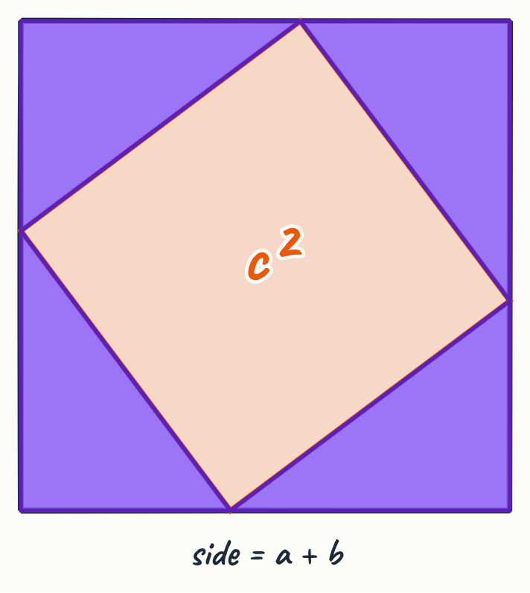
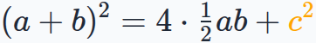
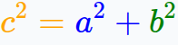
- Outer square has side a + b, and four triangles each have area one half times a times b
- The tilted central square has area c²
- Rearranged, the leftover space splits into squares of areas a² and b²
- The right angle is essential for the triangles to fill the corners exactly

6. Extensions and the limits of the theorem
The theorem extends to coordinate geometry, where the distance between two points is the square root of the sum of squared differences in x and y. It also generalises to three dimensions, where a box diagonal is the square root of a² + b² + c². For triangles without a right angle, the law of cosines adds a correction term, c² = a² + b² − 2ab cos C, and the extra term vanishes when the angle C is ninety degrees.
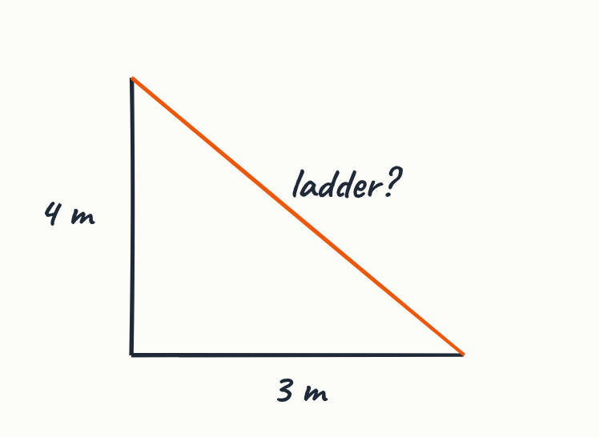
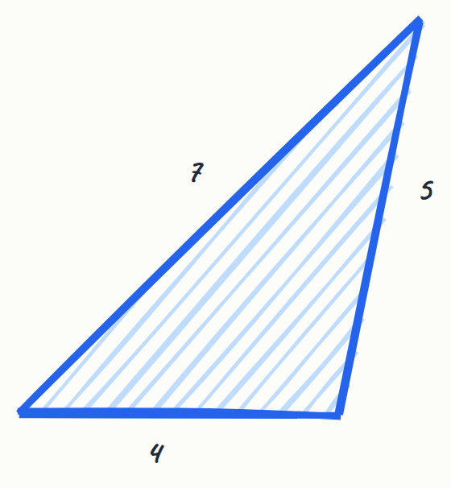
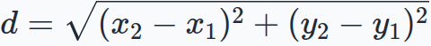
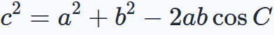
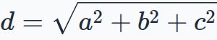
- Coordinate distance: d = square root of (x₂ − x₁)² + (y₂ − y₁)²
- Box diagonal in three dimensions: d = square root of a² + b² + c²
- For any triangle, the law of cosines reduces to the Pythagorean theorem at ninety degrees
- Applying a² + b² = c² to a non-right triangle is a common mistake

Key terms
Law of cosines | A generalisation of the Pythagorean theorem to any triangle, with a cosine correction term for the angle between the two known sides.

7. Real-world application
The theorem gives practical answers in everyday measurement. A ladder whose foot is three metres from a wall and whose top is four metres up is the hypotenuse of a right triangle, so it is five metres long. The same reasoning is used for diagonal braces and for shortest straight-line distances on maps.
- Ladder example: 3 m base, 4 m height, ladder length 5 m
- Diagonal braces in structures use the same calculation
- Shortest straight-line distances on maps are hypotenuse calculations

Key points
- In a right triangle with legs a and b and hypotenuse c, a² + b² = c².
- The theorem is a statement about areas: the squares on the legs together equal the square on the hypotenuse.
- The right angle is essential; the relation fails for other triangles, where the law of cosines applies instead.
- Rearrangement proofs show the theorem holds by comparing two arrangements of the same area.
- The theorem extends to coordinate distances and to three-dimensional diagonals.

Summary
The Pythagorean theorem states that in a right triangle, the squares on the two legs have a combined area equal to the square on the hypotenuse, written a² + b² = c². It can be verified with a 3-4-5 example and proved by rearranging four copies of the triangle inside a larger square. The theorem depends on the right angle, and it extends to coordinate distances and three-dimensional diagonals. Its practical uses range from ladder lengths to map distances.

Practice questions
1. A right triangle has legs of 6 and 8. What is the hypotenuse?
______________________________________________________________________
2. A right triangle has a hypotenuse of 13 and one leg of 5. Find the other leg.
______________________________________________________________________
3. Why can you not use a² + b² = c² for a triangle with sides 4, 5 and 6?
______________________________________________________________________
4. Why must the positive square root be taken when finding a length from c²?
______________________________________________________________________
5. Find the distance between the points (1, 2) and (4, 6).
______________________________________________________________________

Quick quiz
1. A triangle has sides 5, 6 and 8. Is it a right triangle?
(a) Yes, because the longest side is the hypotenuse
(b) No, because 25 + 36 = 61, which is not 64
(c) Yes, because 5 + 6 is greater than 8

Answer key

Practice questions
1. 6² + 8² = 36 + 64 = 100, so c = √100 = 10.
2. a² = c² − b² = 169 − 25 = 144, so a = 12.
3. Because the triangle is not right-angled: 4² + 5² = 41 while 6² = 36, so the equation fails. The law of cosines applies instead.
4. A length cannot be negative, so only the non-negative square root is a valid side length.
5. d = √((4 − 1)² + (6 − 2)²) = √(9 + 16) = √25 = 5.

Quick quiz
1. (b) No, because 25 + 36 = 61, which is not 64 — Having a longest side does not make it right-angled; the squares must actually satisfy a squared plus b squared equals c squared.

